

STATE MONITORING OF OVERHEAD TRANSMISSION LINES USING IOT-ENABLED MULTI-SENSOR NETWORKS

A PROJECT REPORT

Submitted by

VIMALA N
ASHTA LAKSHMI K NANDHINI M RAGA VARSHINI S
922322105008
922322105012
922322105021
922322105025

In partial fulfilment for the award of the degree

Of

BACHELOR OF ENGINEERING IN

ELECTRICAL AND ELECTRONICS ENGINERRING UNIVERSITY COLLEGE OF ENGINEERING
DINDIGUL 624622

ANNA UNIVERSITY::CHENNAI 600 025

APRIL 2026

BONAFIDE CERTIFICATE
Certified that this project report “STATE MONITORING OF OVERHEAD TRANSMISSION LINES USING IOT-ENABLED MULTI-
SENSOR NETWORKS” is the Bonafide work of “VIMALA.N (922322105008), ASHTA LAKSHMI.K (922322105012), NANDHINI.M (922322105021) and RAGA VARSHINI.S (922322105025)” who carried out
the project under my supervision.

SIGNATURE SIGNATURE

Dr.M.SENTHILKUMAR, M.E.,(PH.D)., Dr.S.VASANTHI, M.E.,(Ph.D).,

HEAD OF THE DEPARTMENT SUPERVISOR

Electrical and Electronics Engineering, Electrical and Electronics Engineering, University College of Engineering, University College of Engineering,
Dindigul-624 622. Dindigul-624 622.

Submitted to Anna University project VIVA-VOCE Examination held on …………..

INTERNAL EXAMINER INTERNAL EXAMINER

ACKNOWLEDGMENT
We express our sincere and heartily thanks to the Dean and Head of the Department, Dr.M.SENTHILKUMAR, M.E., Ph.D., University College of Engineering-Dindigul, who give us permission to move on with our own interest in this project.
We express our sincere thanks to our Project Coordinator, Dr.A.JOSEPH BSANTH, M.E., Ph.D., Department of Electrical and Electronics Engineering, University College of Engineering-Dindigul, for her valuable suggestion and encouragement in the completion of the Project work.
We extend our earnest and sincere thanks to our Project Guide Dr.S.VASANTHI, M.E., Ph.D., Department of Electrical and Electronics Engineering-Dindigul, for his remarkable support and guidance to bring out our best to this project.
Last but not least, we convey our heartly thanks to our beloved parents, teaching staff, non-teaching staff and our friends for their moral support.

ABSTRACT
In the modern power system, transmission lines are essential for delivering electrical energy from generation sources to distribution networks, and their reliability is crucial for uninterrupted power supply. With increasing demand, faults and energy leakage in transmission lines have become significant challenges affecting system performance. To address this, the proposed system presents an intelligent and automated fault detection mechanism based on real- time voltage sensing and IoT integration. The system utilizes voltage sensors, regulated power supply units, and an ESP32 microcontroller to continuously monitor voltage levels in the transmission line. Any abnormal variation in voltage is detected instantly, indicating a potential fault condition. Upon detection, a relay module is activated to isolate the faulty section, thereby preventing further damage and reducing energy loss. The system also incorporates a DHT11 sensor to monitor temperature and humidity conditions, along with an MPU6050 sensor to observe line orientation and motion-related changes that may indicate disturbances. A GSM/SIM module is used to send real-time alerts to authorized personnel, ensuring quick response. Real-time monitoring is provided through the ThingSpeak platform. Current and Voltage from generation and distribution sides are shown as real-time graphs using ThingSpeak. Additionally, an LCD display provides local monitoring, and a buzzer gives immediate fault indication. The integration of IoT enables remote monitoring and improves overall system reliability and efficiency.

TABLE OF CONTENTS

CHAPTER NO | TITLE | PAGE NO
 | ACKNOWLEDGEMENT | III
 | ABSTRACT | i
 | TABLE OF CONTENTS | ii
 | LIST OF FIGURES | vi
 | LIST OF ABBREVIATIONS | x
1 | INTRODUCTION
 | 1.1 OVERVIEW | 1
 | 1.2 TYPES OF TRANSMISSION LINE | 2

FAULTS

- CAUSES OF TRANSMISSION LINE 3
FAULTS
- DETECTION AND PROTECTION 3
- CONSEQUENCES OF FAULTS 4
- LITERATURE REVIEW 5
- SYSTEM DESIGN
  - EXISTING SYSTEM 8
    - SYMMETRIC FAULTS 8
    - ASYMMETRIC FAULTS 8
    - 1.3 TRANSIENT FAULTS 9
    - DRAWBACKS 9
  - PROPOSED SYSTEM 10
- BLOCK DIAGRAM 11
- BLOCK DIAGARAM DESCRIPTION 11
    - POWER SUPPLY AND INPUT 12
SECTION
    - VOLTAGE AND CURRENT 12
SENSING MODULE
- ESP32 MICROCONTROLLER 12
UNIT
- ESP32-CAM INTEGRATION FOR 13
ENHANCED MONITORING
- RELAY AND DRIVER CIRCUIT 13
- ENVIRONMENTAL MONITORING 13
SENSORS
- COMMUNICATION MODULES 14
(GSM & IoT)
- DISPLAY AND ALERT SYSTEM 14
- LOAD SECTION AND FAULT 14
ISOLATION
- THINGSPEAK-IoT PLATFORM 14
- SYSTEM REQUIREMENTS
- HARDWARE SPECIFICATIONS 16
  - ESP32 MICROCONTROLLER 16
  - VOLTAGE SENSOR 19
  - CURRENT SENSOR 22
  - DHT11 SENSOR 24
4.1.5 ESP32-CAM 27

 | 6. MPU6050 | 30
 | 7. RELAY MODULE | 32
 | 8. GSM MODULE | 34
 | 9. WI-FI (IoT COMMUNICATION) | 37
 | 10. LCD DISPLAY WITH I2C MODULE | 39
 | INTERFACE
 | 11. BUZZER | 42
 | 12. POWER SUPPLY UNIT | 44
 | 13. STEPDOWN TRANSFORMER | 47
 | 14. POTENTIOMETER | 48
 | 15. BUCK CONVERTER | 49
 | 2. SOFTWARE SPECIFICATION | 50
 | 1. ARDUINO IDE | 50
 | 2. PROTEUS SOFTWARE | 51
 | 3. THINGSPEAK IoT PLATFORM | 54
5 | SYSTEM IMPLEMENTATION
 | 1. CIRCUIT DIAGRAM | 56
 | 2. CIRCUIT DESCRIPTION | 56
 | 3. HARDWARE IMPLEMENTATION | 58
 | 4. SIMULATION USING PROTEUS DESIGN | 63
 | SUITE
 | 5. OUTPUT USING THINGSPEAK | 67
 | 6. LIVE VIDEO MONITORING USING | 71
 | ESP32-CAM MODULE
 | 7. GSM ALERT MESSAGE DURING FAULT | 72
 | CONDITION

RESULTS AND DISCUSSION 74

CONCLUSION 76

REFERENCES 77

LIST OF FIGURES

FIGURE NO | TITLE | PAGENO
1.1 | TRANSMISSION LINE FAULT DETECTION | 2
3.1 | BLOCK DIAGRAM | 11
4.1 | ESP32 | 19
4.2 | VOLTAGE DETECTION SENSOR MODULE | 21
 | O-25 V
4.3 | CURRENT SENSOR ACS712-30A | 24
4.4 | DHT11 SENSOR | 27
4.5 | ESP32-CAM | 29
4.6 | MPU6050 6-AXIS ACCELEROMETER & | 32
 | GYROSCOPE SENSOR MODULE
4.7 | RELAY MODULE | 34
4.8 | GSM MODULE | 37
4.9 | WI-FI | 39
4.10 | LCD WITH I2C MODULE | 42
4.11 | BUZZER | 44
4.12 | POWER SUPPLY UNIT | 47
4.13 | STEPDOWN TRANSFORMER | 48
4.14 | POTENTIOMETER | 48
4.15 | BUCK CONVERTER | 49

ARDUINO IDE 50

ARDUINO IDE DISPLAY IN DETAIL 51

PROTEUS SOFTWARE 52

CIRCUIT SIMULATION USING PROTEUS 53

DESIGN SUITE

PCB LAYOUT DESIGN IN PROTEUS ARES 53

MODULE

THINGSPEAK 54

THINGSPEAK ANALYTICS 55

CIRCUIT DIAGRAM 56

HARDWARE CONNECTION SETUP 58

COMPLETE HARDWARE 59

IMPLEMENTATION OF TRANSMISSION LINE FAULT DETECTION SYSTEM

FAULT FREE OPERATION OF THE 60

SYSTEM

GENERATION SIDE FAULT DETECTION 61

OUTPUT

DISTRIBUTION SIDE FAULT DETECTION 62

SYSTEM

SIMULATION CIRCUIT DIAGRAM IN 63

PROTEUS

SIMULATION SETUP OF TRANSMISSION 64

LINE FAULT DETECTION SYSTEM

GENERATION SIDE FAULT SIMULATION 64

OUTPUT

GSM ALERT OUTPUT DURING 65

GENERATION SIDE FAULT CONDITION

DISTRIBUTION SIDE FAULT SIMULATION 65

OUTPUT

GSM ALERT OUTPUT DURING 66

DISTRIBUTION SIDE FAULT CONDITION
  - THINGSPEAK CHANNEL SETUP FOR IoT 67

TRANSMISSION LINE FAULT SYSTEM
  - IoT CLOUD MONITORING DASHBOARD 67

IN THINGSPEAK

VOLTAGE GRAPH ANALYSIS 68

(GENERATIONAND DISTRIBUTION SIDE)

CURRENT GRAPH ANALYSIS 68

(GENERATIONAND DISTRIBUTION SIDE)

TEMPERATURE AND HUMIDITY 69

ANALYSIS USING DHT11 SENSOR

TILT ANGLE ANALYSIS USING MPU6050 69

SENSOR (X & Y AXIS)

DATA IMPORT AND EXPORT OPTIONS 70

IN THINGSPEAK

LIVE VIDEO MONITORING USING ESP32 71

CAM MODULE

GSM ALERT MESSAGE DURING FAULT 72

CONDITION

 | LIST OF ABBREVATIONS
SLG | SINGLE LINE TO GROUND FAULT
LL | LINE TO LINE FAULT
LG | LINE TO GROUND FAULT
SCADA | SUPERVISORY CONTROL AND DATA ACQUISITION
IoT | INTERNET OF THINGS
LLG | LINE TO LINE GROUND FAULT
ESP32 | EXPRESSIF 32 BIT MICROCONTROLLER
DHT11 | DIGITAL HUMIDITY AND TEMPERATURE SENSOR
MPU6050 | MOTION PROCESSING UNIT 6050
ESP32-CAM | ESP32-CAMERA MODULE
GSM | GLOBAL SYSTEM FOR MOBILE COMMUNICATION
LCD | LIQUID CRYSTAL DISPLAY
AC | ALTERNATING CURRENT
DC | DIRECT CURRENT
WI-FI | WIRELESS FIDELITY
MATLAB | MATRIX LABORATORY
LCD I2C | LIQUID CRYSTAL DISPLAY WITH
 | INTER-INTEGRATED CIRCUIT MODULE
ARDUINO IDE | ARDUINO INTEGRATED DEVELOPMENT
 | ENVIRONMENT

ADC | ANALOG TO DIGITAL CONVERTER
DMP | DIGITAL MOTION PROCESSOR
SDA | SERIAL DATA LINE
SCL | SERIAL CLOCK LINE
NO | NORMALLY OPEN
NC | NORMALLY CLOSE
UART | UNIVERSAL ASYNCHRONOUS RECEIVER
 | TRANSMITTER
SIM | SUBSCRIBER IDENTITY MODULE
SMS | SHORT MESSAGE SERVICE
TXRX | TRANSMIT/RECEIVE
SSID | SERVICE SET IDENTIFIER
HTTP | HYPER TEXT TRANSFER PROTOCOL
JSON | JAVA SCRIPT OBJECT NOTATION
C++ | GENERAL PURPOSE PROGRAMMING LANGUAGE
IDE | INTEGRATED DEVELOPMENT ENVIROINMENT
STM32 | STMICRO ELECTRONICS 32 BIT MICROCONTROLLER
EDA | ELECTRONIC DESIGN AUTOMATION
ISIS | INTELLIGENT SCHEMATIC INPUT SYSTEM
ARES | ADVANCED ROUTING AND EDITING SOFTWARE
PCB | PRINTED CIRCUIT BOARD

CSV COMMA SEPARATED VALUES

1.1 OVERVIEW

CHAPTER – 1 INTRODUCTION

In electrical utilities, some of the transmission lines plays the major role of every power systems. With regard to this, cost of power delivery, and accurate fault location for the transmission of electric lines is of vital importance in restoring the power services and reducing outage time as much as possible. By an accurate source detecting and finding the exact faults on high voltage transmission network is very important for all the utilities to allow a quick maintenance action for the concern authority of a repairing person or crew. Detecting the cable fault in the underground can be categorized as an open conductor faults, shorted faults, and high impedance faults. It may be occur in the high voltage transmission lines due to the heavy power transmission. This we can able to do using the Arduino microcontroller to monitor the cable in the underground with the use of loaded program in the microcontroller. A short circuit to the earth fault can be mostly located using a method called frame method.
Power supply networks are growing continuously and their reliability getting more important than ever. The complexity of the whole network comprises numerous components that can fail and interrupt the power supply for end user. For most of the worldwide operated low voltage and medium voltage distribution lines, underground cables have been used for many decades. Underground high voltage cables are used more and more because they are not influenced by weather conditions, heavy rain, storm, snow and pollution. Even though the cable manufacturing technology is improving steadily; there are still influences which may cause cable to fail during test and operation. A cable in good condition and installed correctly can last a lifetime of about 30 years. However cables can be easily damaged by incorrect installation or poorly executed jointing, while subsequent third party damage by civil works such as trenching or curb edging.

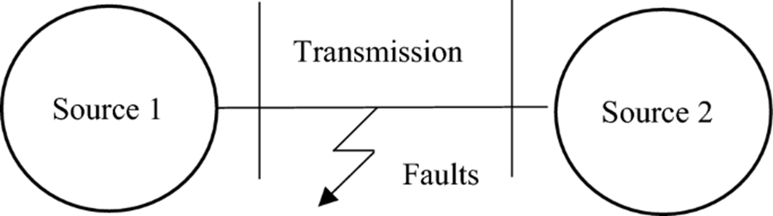

Figure 1.1 Transmission Line Fault Detection

A transmission line fault refers to an abnormal condition that occurs in an electrical transmission line, where the normal flow of electricity is disrupted due to some fault. These faults are typically caused by issues such as physical damage, insulation failure, short circuits, or lightning strikes. Transmission lines are responsible for carrying electrical power from power stations to substations and then to consumers, so faults on these lines can have significant consequences, including power outages, equipment damage, and safety hazards.

1.2. TYPES OF TRANSMISSION LINE FAULTS
Transmission line faults are typically classified based on the nature of the fault and the parts of the system affected. The most common types of faults are:

Short Circuit Faults:
- Single-line-to-ground fault (SLG): One conductor is in contact with the ground, causing a short.
- Line-to-line fault (LL): Two conductors are in contact with each other, creating a short circuit.
- Double-line-to-ground fault (LLG): Two conductors touch the ground.
- Three-phase fault (3-phase): All three conductors make contact either with each other or the ground, which is the most severe type of fault.

Open Circuit Faults:
- Occurs when one or more conductors become disconnected or broken, which can interrupt the current flow.

Ground Faults:

- The fault occurs when a live conductor makes contact with the earth or a grounded part
of the system.

Causes of Transmission Line Faults
  - Weather Conditions: Lightning, storms, and high winds can cause physical damage to the transmission line, leading to faults.
  - Mechanical Failures: Broken conductors, insulator failures, or damage to support structures can lead to faults.
  - Wildlife or Vegetation: Trees or animals may come into contact with the transmission
line, causing a short circuit or other faults.

  - Human Error: Mistakes during construction, maintenance, or operation of the transmission lines can cause faults.
  - Aging and Deterioration of Equipment: Over time, the insulation and conductors can degrade, leading to faults.

Detection and Protection
  - Fault Detection: Faults are typically detected using protection relays that monitor the current and voltage on the transmission line. These devices can quickly detect abnormal conditions.
  - Protection schemes: Transmission lines are equipped with protective devices like circuit breakers and fuses that isolate the faulted section of the line to prevent further damage. Relay systems, including distance protection and overcurrent protection, are commonly used.
    - Overcurrent Protection: Activates when current exceeds a preset threshold.
    - Distance Protection: Monitors the impedance between the fault and the relay, used especially for long transmission lines.
- Automated Systems: In more advanced systems, supervisory Control and Data Acquisition (SCADA) systems are used to monitor and control transmission line conditions remotely.

1.5. Consequences of Faults:

- Power Interruptions: A fault can cause power to be lost for entire regions or even cities.
- Equipment Damage: Faults can cause significant damage to transformers, generators, circuit breakers, and other equipment if not quickly cleared.
- Safety Hazards: Faults can cause fires, electrocution, and other dangerous situations for workers and the public.
Transmission line faults are a critical concern in power systems because they affect the reliability and safety of the electrical grid. Understanding the types, causes, and protection methods for transmission line faults is essential for maintaining an efficient and safe power distribution system.
Remote sensor-based transmission line observations are state-based, not conclusions, through continuous primary cardiac change, faster defect limitation, recognizable evidence and electrical fault isolation from mechanical problem. It offers answers to some concerns, such as cost savings through support. These applications, such as intermittent maintenance, show a serious need to quickly convey huge measurements of exceptionally robust information. The realization of these applications relies on a practical and robust organizational design plan with fast reaction times.
Organizations should provide options for transmitting sensitive information, such as current status and control data of transmission lines between transmission grids. This paper provides an advanced structure of costs for planning an organization of continuous Information delivery. To triage the situation in the force framework, sensors are placed in different parts of the force organization. These sensors are equipped to generate large amounts of data, making detailed estimates of various physical or electrical boundaries. Delivering this data to the control community productively and at an affordable cost is a fundamental test for building a fiercely outstanding network.

CHAPTER – 2 LITERATURE REVIEW

- Title: Transmission Line
Author: Madhan, V. P., et al.
Protection and Hybrid Fault
Detection Using IoT

Year: 2025

Description:

This paper presents a hybrid approach to transmission line protection by combining conventional protection techniques with modern IoT-based monitoring systems. The authors propose a system that utilizes sensors to continuously monitor electrical parameters such as voltage and current, enabling real-time detection of abnormal conditions. The integration of IoT technology allows the collected data to be transmitted to remote monitoring stations, where it can be analysed for fault identification and system diagnostics. The study emphasizes the importance of combining hardware-based protection mechanisms, such as relays and circuit breakers, with intelligent software-based monitoring systems to achieve faster and more accurate fault detection. The proposed system is designed to automatically isolate the faulty section using relay control, thereby preventing damage to equipment and reducing power loss. Additionally, the system provides real-time alerts to authorized personnel through communication modules, ensuring timely response and maintenance. The authors also discuss the advantages of IoT integration, including remote accessibility, scalability, and reduced dependency on manual inspection. The paper highlights practical implementation aspects, making the proposed system suitable for real-world applications. Furthermore, the research demonstrates that hybrid systems significantly improve the reliability and efficiency of power transmission networks by enabling continuous monitoring and quick fault response.

- Title: Performance Assessment of Transmission Line Faults in Power System
Author: Sahu, Rupesh, et al.

Year: 2025

Description:

This research focuses on analysing the performance of power transmission lines under different fault conditions to better understand system behaviour and improve protection

strategies. The authors conduct detailed simulations to study various types of faults, including single line-to-ground faults, line-to-line faults, double line-to-ground faults, and three-phase faults. The paper examines key electrical parameters such as fault current magnitude, voltage variations, and system stability during fault conditions. By analysing these parameters, the study provides insights into how different types of faults affect the performance and reliability of the power system. The authors also evaluate the effectiveness of existing protection schemes and identify areas where improvements are needed. The research highlights the importance of accurate fault detection and classification in maintaining system stability and preventing equipment damage. Additionally, the study discusses the impact of fault location on system performance and the challenges associated with identifying fault locations accurately. The findings of this paper contribute to the development of more efficient fault detection and protection systems by providing a deeper understanding of fault characteristics and system responses.

- Title: Fault Detection in
Author: Behera, Saswati Kumari, et al.
Transmission Line by Using IoT

Year: 2024

Description:

This paper proposes an IoT-based system for detecting faults in transmission lines through continuous monitoring of electrical parameters. The authors design a system that incorporates sensors, microcontrollers, and communication modules to collect and transmit data in real time. The system monitors voltage and current levels in the transmission line and identifies abnormalities that may indicate fault conditions. The collected data is transmitted to a remote server or cloud platform, allowing operators to monitor the system from any location. The study highlights the advantages of IoT technology in improving fault detection speed and reducing manual intervention. It also emphasizes the importance of real-time data analysis in preventing system failures and improving reliability. The proposed system is cost-effective and scalable, making it suitable for large-scale implementation in modern power grids. Additionally, the authors discuss the challenges associated with IoT-based systems, such as data security, communication reliability, and system integration. The research demonstrates that IoT-based fault detection systems can significantly enhance the efficiency and reliability of power transmission networks.

- Title: Enhancing Power Grid Reliability in Bangladesh: An IoT-Based Approach to Transmission Line Fault Detection
Author: Alam, Md Nahidul, et al.

Year: 2024

Description:

This study focuses on improving the reliability of power grids through the implementation of an IoT-based transmission line fault detection system. The authors propose a system that integrates sensors, communication technologies, and cloud-based platforms to monitor transmission line conditions in real time. The system continuously collects data on electrical parameters and transmits it to a central monitoring system for analysis. The study emphasizes the importance of reliable communication networks in ensuring effective fault detection and response. The proposed system enables quick identification of faults and provides real-time alerts to maintenance personnel, reducing downtime and improving system performance. The authors also discuss the challenges faced in implementing IoT-based systems in developing regions, such as infrastructure limitations and data management issues. Despite these challenges, the research demonstrates that IoT technology can significantly enhance the reliability and efficiency of power transmission systems.

CHAPTER – 3 SYSTEM DESIGN

EXISTING SYSTEM
Transmission Line Fault Detection is a crucial aspect of the electrical power system that helps to ensure the stability and reliability of the power supply by detecting and isolating faults in the transmission line. In recent years, many researchers have focused on developing advanced electrical components and techniques for transmission line fault detection. In this literature survey, we will review some of the recent research works in this field. Effective positioning of the relay medium in the network will detect any interruption in the power system. The key issue in the transmission system is usually fault detection. If the fault happens during the power swing, then the fault diagnosis is a tedious one. Early detection of faults is important to ensure the performance of the distributed system. Although there are many solutions for fault detection, it is still a challenge to manage the complexity and uncertainty of system observations to make an accurate detection. For a reliable and high speed protective relay followed by digital distance safety, fault classifications more important. It is a summary of a brief introduction of transmission line faults and a review of the scope of various old approaches in this area. In this report, we present a review study on the detection of faults using machine learning techniques.

SYMMETRIC FAULTS

In a three-phase system, if a fault affects all three phases equally, it is called a symmetric
or a balanced fault. Generally symmetric faults constitute about 5% of the total faults.

ASYMMETRIC FAULTS
An unbalanced fault or asymmetric fault results in unequal effect of fault on each of the three phases. Asymmetric faults are further classified as LL or Line to Line fault, LG or Line to Ground fault and LLG or Double Line to Ground fault.
  - LL fault is a short circuit between two lines, caused by ionization of air, or when lines come into physical contact, for example due to a broken insulator.
  - LG Fault is a short circuit between one line and ground due to physical contact caused
by lightning or storm.

  - LLG fault occurs when two lines come in contact with the ground and each other. This is mainly caused by storm damage.

TRANSIENT FAULTS

In a system, if a fault diminishes when power is disconnected for a short period of time and then restored, the fault is referred as a transient fault. A transient fault may also be an insulation fault that temporarily affects a device’s dielectric properties. Transient faults may be caused due to momentary tree contact, animal contact, lightning strike, etc.
In a different study, researchers proposed the use of microcontroller-based systems for transmission line fault detection. The proposed system used a relay module, a thermistor temperature sensor, and a transformer to detect and isolate faults in the transmission line. The results showed that the proposed system was able to accurately detect faults in the transmission line and was able to improve the stability and reliability of the power system.
In conclusion, the literature survey shows that there is a significant amount of research work being done in the field of transmission line fault detection. Researchers are developing advanced electrical components and techniques to improve the accuracy and reliability of fault detection systems. The use of artificial intelligence algorithms, digital signal processing techniques, and microcontroller-based systems are some of the recent approaches being used for transmission line fault detection. The implementation of these advanced techniques is expected to significantly improve the stability and reliability of the electrical power system.

DRAWBACKS

Transmission line faults are a major problem in the electrical power system and can cause significant disruption in the power supply. Some of the main problems associated with transmission line faults include:
  - Power Outages: Transmission line faults can result in power outages, which can affect both residential and commercial customers. This can cause significant inconvenience and financial losses, especially for businesses that rely on a constant power supply.
  - Equipment Damage: Transmission line faults can cause damage to electrical equipment, such as transformers and capacitors, which can be costly to repair or replace.

  - Increased Energy Losses: Faults in the transmission line can result in increased energy losses, which can have a significant impact on the efficiency of the electrical power system.
  - Safety Hazards: Transmission line faults can also pose a safety hazard, as they can cause electrical arcs and fires. This can put both the public and electrical workers at risk.
  - Reduced Reliability: Faults in the transmission line can reduce the reliability of the electrical power system, as they can result in power outages and disruptions in the power supply.

PROPOSED SYSTEM

The proposed system is an IoT-based transmission line monitoring and fault detection system developed using the ESP32 microcontroller to ensure safe and reliable power distribution. The system continuously monitors key electrical parameters such as voltage and current using dedicated sensors. A voltage sensor measures the line voltage, while two current sensors are used to compare input and output current, enabling accurate detection of faults like leakage, overload, and short circuits. All sensor data is processed by the ESP32, which identifies abnormal conditions based on predefined thresholds and responds immediately. To improve system intelligence, environmental monitoring is included using the DHT11 sensor for temperature and humidity, and the MPU6050 sensor for motion detection. These sensors help in identifying external factors that may affect transmission line performance. When a fault is detected, the ESP32 activates a relay through a driver circuit to disconnect the load and prevent damage. Additionally, an ESP32-CAM module provides visual monitoring by capturing images during fault conditions, enabling better analysis and faster maintenance. The system also integrates GSM and IoT communication for real-time alerts and remote monitoring. Fault notifications are sent instantly to users via GSM, while system data is uploaded to a cloud platform using Wi-Fi. An LCD display shows real-time parameters locally, and a buzzer provides immediate alerts. Overall, the proposed system offers an efficient, automated, and intelligent solution by combining sensing, control, communication, and monitoring features into a compact design.

BLOCK DIAGRAM

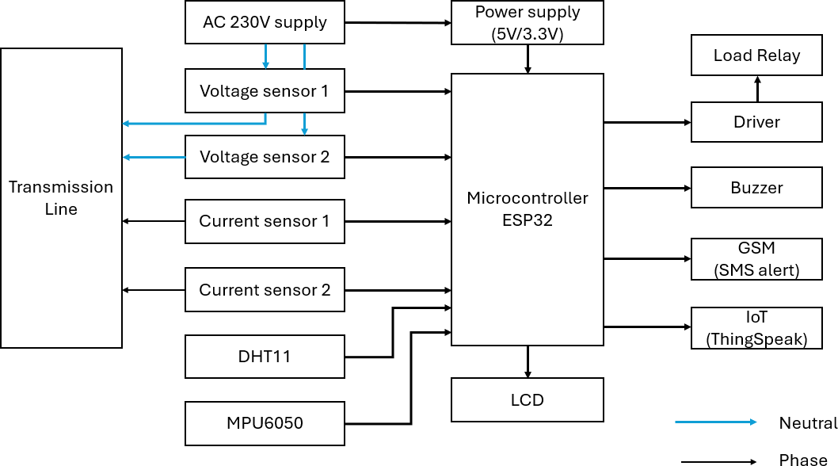

Figure 3.1 Block Diagram

  - Block Diagram Description

The proposed system represents an intelligent transmission line monitoring and fault detection setup designed using an ESP32 microcontroller integrated with multiple sensing, control, and communication modules. The main objective of the system is to continuously monitor voltage and current parameters in a transmission line, detect abnormalities, and take necessary actions such as isolating faulty sections and notifying authorities. The system operates using an AC 230V supply, which is stepped down and regulated through a power supply unit to provide suitable DC voltage levels for electronic components. The ESP32 acts as the central processing unit, receiving inputs from various sensors and controlling output devices such as relays, LCD display, GSM module, and IoT (ThingSpeak ) interface. The integration of sensors like voltage sensors, current sensors (C1 and C2), DHT11, and MPU6050 enhances the system’s ability to monitor both electrical and environmental conditions. Current and Voltage from generation and distribution sides are shown as real-time graphs using ThingSpeak. The inclusion of communication modules ensures that real-time data can be transmitted for remote monitoring and control.

Power Supply and Input Section

The system is powered by an AC 230V supply, which is converted into a regulated DC voltage using a power supply unit. This regulated power is essential for the safe and efficient operation of the ESP32 and associated modules. The power supply ensures stable voltage levels, preventing damage to sensitive electronic components. The AC supply is also connected to the relay module, which controls the flow of power to the transmission line and load. Proper isolation and regulation are maintained to ensure that high voltage does not directly affect the low-voltage control circuitry. This section plays a critical role in maintaining system reliability and ensuring uninterrupted operation.

Voltage and Current Sensing Module
The system incorporates voltage and current sensing mechanisms to continuously monitor the electrical parameters of the transmission line. The voltage sensor measures the line voltage and provides an analog signal to the ESP32 for analysis. Two current sensors, namely C1 (input current sensor) and C2 (output current sensor), are used to measure the current flowing into and out of the transmission line. By comparing the input and output current values, the system can detect any imbalance or leakage in the line, which may indicate a fault condition. These sensors provide real-time data, enabling the microcontroller to identify abnormalities such as overcurrent, under-voltage, or leakage. This sensing mechanism forms the core of the fault detection process, ensuring accurate and timely identification of issues in the transmission line.

ESP32 Microcontroller Unit

The ESP32 microcontroller serves as the central processing unit of the system, responsible for data acquisition, processing, and control operations. It receives input signals from voltage and current sensors, as well as environmental sensors like DHT11 and MPU6050. The ESP32 processes this data using programmed algorithms to detect fault conditions based on predefined thresholds. Once a fault is identified, the microcontroller generates control signals to activate the relay module and isolate the faulty section. Additionally, the ESP32 manages communication with the GSM module and IoT platform, enabling real-time data transmission and remote monitoring. Its built-in Wi-Fi capability makes it highly suitable for IoT applications, allowing seamless integration with web-based monitoring systems.

ESP32-CAM Integration for Enhanced Monitoring

In addition to the existing system, an ESP32-CAM module can be integrated to provide visual monitoring and advanced surveillance capabilities for the transmission line environment. The ESP32-CAM is a compact camera module with built-in Wi-Fi, capable of capturing images and streaming video in real time. By incorporating this module into the system, it becomes possible to visually inspect the condition of transmission lines, detect physical damages such as broken conductors, sparks, or external disturbances, and verify fault conditions more accurately. The ESP32-CAM operates alongside the main ESP32 microcontroller and can be triggered during abnormal conditions or scheduled intervals to capture and transmit images. The captured images or video streams can be sent to a cloud server or IoT platform, enabling remote monitoring through a web interface or mobile application. This feature significantly enhances the system’s capability by providing visual evidence of faults, which helps maintenance personnel make quicker and more informed decisions. Additionally, the ESP32- CAM can be programmed to work with motion detection or event-based triggers, ensuring efficient use of bandwidth and storage. The integration of visual monitoring with electrical parameter sensing creates a more comprehensive fault detection system, improving reliability, reducing inspection time, and enabling smarter maintenance strategies in modern power transmission networks.

Relay and Driver Circuit

The relay module plays a crucial role in controlling the power flow to the load. It acts as a switching device that can disconnect the load in case of a detected fault. Since the ESP32 operates at low voltage levels, a driver circuit is used to interface the microcontroller with the relay. The driver circuit amplifies the control signal from the ESP32 to a level sufficient to operate the relay. When a fault is detected, the ESP32 sends a signal to the driver, which in turn activates the relay to cut off the power supply to the load. This mechanism helps in preventing damage to equipment and ensures safety in the power system.

Environmental Monitoring Sensors
The system includes a DHT11 sensor to measure temperature and humidity levels around the transmission line. Monitoring environmental conditions is important as extreme temperature or humidity can affect the performance and reliability of electrical components. Additionally, the MPU6050 sensor is used to detect orientation and motion-related changes, which may indicate physical disturbances or structural issues in the transmission line. These

sensors provide supplementary data that enhances the overall monitoring capability of the system, enabling more comprehensive fault analysis.

Communication Modules (GSM and IoT)
The communication section of the system consists of GSM and IoT modules that enable real-time data transmission and remote monitoring. The GSM module is used to send alert messages to authorized personnel when a fault is detected. This ensures immediate notification and quick response to potential issues. The IoT module, powered by the ESP32’s Wi-Fi capability, allows the system to upload data to a cloud platform or web server. Users can monitor system parameters such as voltage, current, temperature, and fault status from anywhere using an internet connection. This feature significantly improves the efficiency and accessibility of the monitoring system.

Display and Alert System
The system is equipped with an LCD display that provides real-time information about system parameters and fault conditions. The display shows values such as voltage, current, temperature, and system status, allowing local monitoring. In addition to the visual display, a buzzer is used to provide audible alerts when a fault is detected. This ensures that immediate attention is drawn to the issue, even if the operator is not actively monitoring the display.

Load Section and Fault Isolation
The load section represents the end user or equipment connected to the transmission line. The system ensures that the load receives a stable and safe power supply under normal conditions. However, when a fault is detected, the relay module isolates the load from the power source to prevent damage. The use of both voltage and current sensing allows accurate detection of faults such as short circuits, overloads, and leakage currents. This isolation mechanism enhances system safety and reliability.

ThingSpeak – IoT Platform

In this project, ThingSpeak is used to visualize and monitor the system outputs in the form of graphs. A total of eight parameters are displayed, including voltage at the generation side (Voltage 1), voltage at the distribution side (Voltage 2), current at the generation side (Current 1), current at the distribution side (Current 2), temperature and humidity values from the DHT11 sensor, and the X and Y axis values from the MPU6050 sensor. All these parameters

are presented as individual graphs, making it easy to observe and analyse system performance. The system enables real-time monitoring of all sensor data through the ThingSpeak cloud platform, and the data can be accessed remotely from anywhere using the internet. The graphical representation of voltage and current helps in identifying abnormalities and detecting faults effectively. In addition, ThingSpeak stores historical data, which can be used for future analysis and comparison. The recorded data can also be exported and viewed in the form of an Excel sheet for further evaluation and documentation. Furthermore, the platform supports MATLAB analytics for advanced data processing. Overall, ThingSpeak provides an efficient IoT-based solution for data monitoring, visualization, and analysis, thereby enhancing the performance and reliability of the system.

CHAPTER - 4

SYSTEM REQUIREMENTS

Hardware Requirements

  - ESP 32 Microcontroller
  - Voltage Sensor
  - Current Sensor
  - DHT 11
  - ESP 32 CAM
  - MPU6050
  - Relay Control
  - Transformer
  - GSM
  - Wi-Fi
  - LCD with I2C Module
  - Buzzer
  - Potentiometer
  - Buck Converter
  - Power Supply

Software Requirements

  - Arduino IDE
  - Proteus Software
  - ThingSpeak IoT Platform

Hardware Specification

ESP32 Microcontroller

The ESP32 microcontroller serves as the central processing unit and the brain of the entire transmission line monitoring and fault detection system. It is a powerful, low-cost, and energy-efficient microcontroller developed with built-in Wi-Fi and Bluetooth capabilities, making it highly suitable for Internet of Things (IoT) applications. In this project, the ESP32 is responsible for acquiring data from various sensors such as voltage sensors, current sensors,

DHT11, and MPU6050, processing this data in real time, and taking appropriate control actions. It also manages communication with external modules like GSM, LCD, buzzer, relay driver, and IoT platforms. Due to its high processing speed and multiple input/output pins, the ESP32 enables efficient integration of multiple components into a single intelligent system.

Data Acquisition and Sensor Integration

One of the primary functions of the ESP32 in this system is to collect real-time data from different sensors connected to the transmission line setup. The voltage sensor provides analog signals corresponding to the line voltage, while current sensors (C1 and C2) measure the input and output current of the transmission line. These analog signals are converted into digital values using the built-in Analog-to-Digital Converter (ADC) of the ESP32. Additionally, the DHT11 sensor supplies temperature and humidity data, and the MPU6050 provides motion and orientation data through I2C communication. The ESP32 continuously reads and processes these inputs, ensuring that all parameters are monitored simultaneously. This multi-sensor integration capability allows the system to perform comprehensive analysis and detect abnormalities accurately.

Data Processing and Fault Detection Logic
After acquiring data from sensors, the ESP32 processes the information using embedded programming logic. The system is programmed with predefined threshold values for voltage, current, temperature, and motion conditions. The ESP32 continuously compares real-time sensor data with these threshold values to identify abnormal conditions. For example, a sudden drop or rise in voltage, imbalance between input and output current, or unusual environmental changes can indicate a fault in the transmission line. Once such conditions are detected, the ESP32 classifies the fault and initiates appropriate actions. This intelligent decision-making capability makes the system autonomous and reduces the need for manual supervision.

Control of Relay and Protection Mechanism
The ESP32 plays a crucial role in controlling the relay module, which is used to isolate the faulty section of the transmission line. Since the ESP32 operates at low voltage levels, it sends control signals to a driver circuit that activates the relay. When a fault is detected, the ESP32 immediately triggers the relay to disconnect the load from the power supply, preventing damage to electrical equipment and ensuring safety. This rapid response mechanism is essential

for minimizing energy loss and protecting the system from further complications. The relay control is fully automated and operates based on real-time analysis performed by the ESP32.

Communication and IoT Integration
Another important function of the ESP32 in this project is enabling communication through Wi-Fi and IoT platforms. The built-in Wi-Fi capability allows the ESP32 to connect to a network and transmit data to cloud servers or web applications.This enables remote monitoring of transmission line parameters such as voltage, current, temperature, and fault status. The ESP32 also communicates with the GSM module to send alert messages to authorized personnel during fault conditions. This dual communication capability ensures that the system provides both local and remote notifications, improving responsiveness and system reliability. The IoT integration transforms the system into a smart monitoring solution that can be accessed from anywhere.

Interfacing with Display and Alert Systems
The ESP32 is responsible for controlling output devices such as the LCD display and buzzer. The LCD is used to display real-time system parameters, including voltage levels, current readings, temperature, and fault status. This allows users to monitor the system locally without requiring external devices. In addition, the ESP32 activates the buzzer during fault conditions to provide an immediate audible alert. This ensures that even if the operator is not actively monitoring the display, they are still notified of any issues. The coordination between the ESP32 and these output devices enhances user interaction and system usability.

Power Efficiency and Reliability
The ESP32 is designed to operate efficiently with low power consumption, making it suitable for continuous monitoring applications. It supports various power-saving modes, ensuring that the system remains energy efficient while maintaining performance. The reliability of the ESP32 is another key factor that makes it ideal for this project. Its robust architecture allows it to handle multiple tasks simultaneously without performance degradation. This ensures that sensor data acquisition, processing, communication, and control operations are carried out seamlessly.
In the ESP32 microcontroller acts as the central controller that integrates all components of the transmission line monitoring system. It performs critical functions such as data acquisition, processing, fault detection, control of protection mechanisms,

communication, and user interface management. Its ability to handle multiple operations efficiently makes the system intelligent, automated, and reliable. The use of ESP32 significantly enhances the overall performance of the project by enabling real-time monitoring, quick fault response, and remote accessibility, making it a key component in modern IoT-based power system applications.

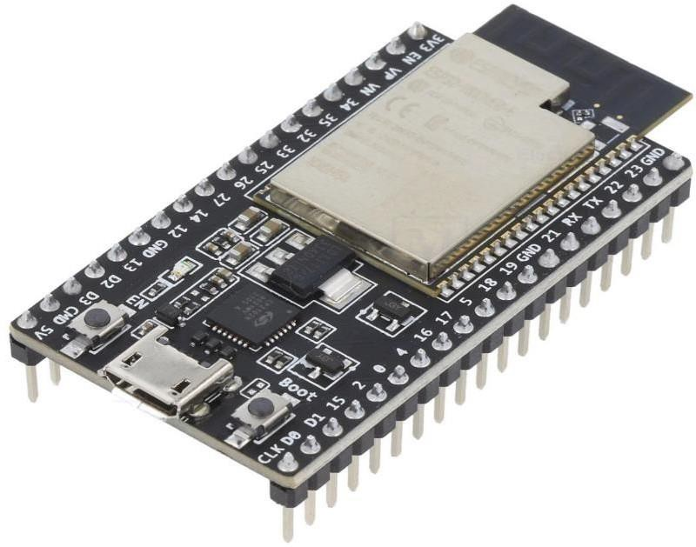

Figure 4.1 ESP32

    - Voltage Sensor

The voltage sensor plays a vital role in the proposed transmission line monitoring system by continuously measuring the voltage levels present in the electrical line. In power systems, voltage is one of the most critical parameters used to determine the health and stability of the transmission network. Any abnormal variation such as overvoltage, undervoltage, or sudden fluctuations can indicate the presence of faults. In this project, the voltage sensor is used to safely step down and measure high transmission line voltage and convert it into a low- level signal that can be processed by the ESP32 microcontroller. This enables real-time monitoring and analysis without exposing sensitive electronics to high voltage levels.

Working Principle of Voltage Sensor
The voltage sensor operates based on the principle of voltage division, where high input voltage is reduced to a proportional lower voltage using resistor networks or voltage divider circuits. In some cases, isolation techniques such as transformers or opto-isolators are also used to ensure safety between high voltage and control circuits. The sensor takes the input voltage

from the transmission line and produces a corresponding analog output signal. This analog signal is then fed into the Analog-to-Digital Converter (ADC) of the ESP32. The microcontroller converts this analog signal into digital values, which are then processed to determine the actual voltage level. The scaling factor is applied in the software to accurately reconstruct the original voltage value.

Integration with ESP32 Microcontroller
The voltage sensor is directly connected to one of the analog input pins of the ESP32. The ESP32 continuously reads the sensor output using its built-in ADC channels. The microcontroller samples the voltage at regular intervals to ensure real-time monitoring. These readings are then calibrated and converted into actual voltage values using predefined formulas in the program. The ESP32 compares the measured voltage with predefined threshold values to detect abnormal conditions. If the voltage exceeds or falls below safe limits, the system interprets it as a fault condition. This integration enables seamless communication between the sensing unit and the control unit.

Role in Fault Detection

The voltage sensor is one of the primary components used for fault detection in the system. It helps in identifying various types of faults such as voltage drops due to line breaks, overvoltage caused by short circuits, and irregular fluctuations due to unstable supply conditions. By continuously monitoring voltage levels, the system can detect even minor deviations from normal operating conditions. When such deviations are detected, the ESP32 processes the data and determines whether the condition is temporary or critical. If a critical fault is identified, appropriate actions such as triggering the relay are initiated. This makes the voltage sensor essential for early fault detection and system protection.

Safety and Isolation Considerations

Since the transmission line operates at high voltage levels, safety is a major concern in the design of the voltage sensing circuit. The voltage sensor ensures that the high voltage is properly stepped down before being fed into the ESP32. Isolation techniques are often used to prevent electrical hazards and protect the microcontroller from damage. Proper grounding and insulation are maintained to ensure safe operation. These safety measures make the voltage sensor reliable and suitable for real-time monitoring applications in power systems.

Contribution to IoT Monitoring

The data obtained from the voltage sensor is not only used for local processing but also transmitted to IoT platforms for remote monitoring. The ESP32 sends voltage readings over Wi-Fi to a cloud server or web application, where the data can be visualized and analyzed. This allows users to monitor voltage conditions in real time from any location. In case of abnormal voltage conditions, alerts can be generated and sent to users via GSM or IoT notifications. This enhances the overall functionality of the system and ensures continuous supervision of the transmission line.

Advantages of Using Voltage Sensor
The use of a voltage sensor in this project provides several advantages. It enables accurate and continuous monitoring of voltage levels, ensuring early detection of faults. It improves system safety by preventing direct exposure of high voltage to electronic components. The sensor is cost-effective, easy to integrate, and reliable for long-term operation. Additionally, it supports real-time data acquisition and analysis, which is essential for automated fault detection systems. In the voltage sensor is a crucial component in the proposed transmission line monitoring system. It provides real-time voltage measurements, enabling the detection of abnormalities and faults in the system. Its integration with the ESP32 allows efficient data processing and decision-making. By ensuring safe voltage measurement and contributing to both local and remote monitoring, the voltage sensor enhances the reliability, safety, and performance of the overall system.

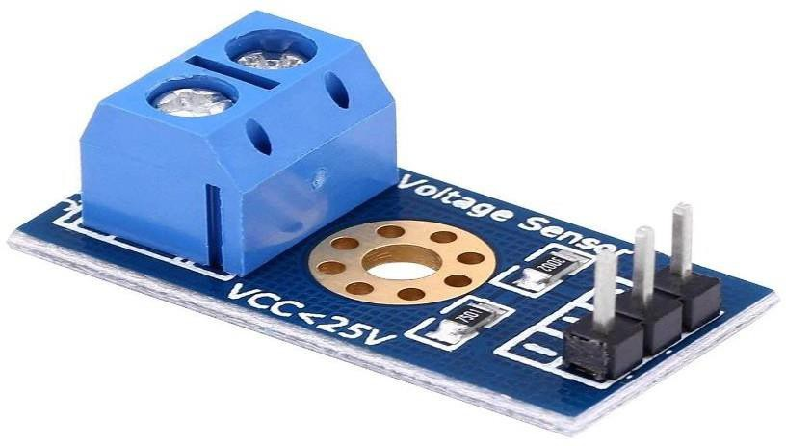

Figure 4.2 Voltage Detection Sensor Module – 0 – 25V

    - Current sensor (C1 & C2)

The current sensor is an essential component in the proposed transmission line monitoring system, used to measure the flow of electric current through the transmission line. In this project, two current sensors are employed, namely C1 (input current sensor) and C2 (output current sensor). The main purpose of using two sensors is to compare the incoming and outgoing current values in the transmission line. This comparison helps in detecting abnormalities such as leakage current, short circuits, or line faults. Current measurement is a critical parameter in power system analysis because any imbalance or sudden variation in current flow directly indicates potential faults. By integrating current sensors with the ESP32 microcontroller, the system ensures continuous monitoring and accurate fault detection.

Working Principle of Current Sensor

The current sensor operates based on the principle of electromagnetic induction or Hall effect, depending on the type used in the system. When current flows through a conductor, it generates a magnetic field around it. The sensor detects this magnetic field and converts it into a proportional electrical signal. In Hall effect-based sensors, a Hall element produces a voltage when exposed to a magnetic field, which is directly proportional to the current flowing through the conductor. This output signal is usually analog and needs to be converted into digital form for processing. The sensor provides isolation between the high-current line and the low-voltage control circuit, ensuring safe operation.

Dual Sensor Configuration (C1 and C2)

The use of two current sensors in this system is a significant design feature that enhances fault detection capability. The first sensor, C1, is placed at the input side of the transmission line to measure the incoming current, while the second sensor, C2, is placed at the output side to measure the outgoing current. Under normal operating conditions, the input and output currents should be approximately equal. However, if there is any leakage, fault, or energy loss in the transmission line, a difference will occur between these two values. The ESP32 continuously compares these readings, and any deviation beyond a predefined threshold is treated as a fault condition. This method improves accuracy in detecting faults and helps in identifying the presence of leakage or unauthorized power usage.

Integration with ESP32 Microcontroller

Both current sensors are connected to the analog input pins of the ESP32 microcontroller. The ESP32 reads the analog signals from C1 and C2 using its built-in ADC channels. These signals are then converted into digital values and processed using programmed algorithms. The microcontroller calculates the difference between input and output current values and checks for any imbalance. This real-time processing enables the system to detect faults instantly. The ESP32 also stores and transmits current data for further analysis through IoT platforms. This seamless integration ensures efficient communication between the sensing and processing units.

Role in Fault Detection and Analysis
The current sensors play a key role in identifying different types of faults in the transmission line. For instance, a sudden increase in current may indicate a short circuit, while a decrease may suggest a break in the line. More importantly, the difference between C1 and C2 readings helps in detecting leakage currents, which are often difficult to identify using a single sensor. This dual-sensor approach enhances the reliability of the system and reduces false detections. The ESP32 uses this data to determine the severity of the fault and initiates appropriate actions such as activating the relay to isolate the faulty section.

Safety and Isolation Features

Current sensors provide electrical isolation between the high-current transmission line and the low-voltage control circuitry. This is crucial for protecting the ESP32 and other electronic components from damage. The sensors are designed to handle high current levels safely while providing accurate measurements. Proper installation and calibration of sensors ensure reliable operation and prevent errors in measurement. These safety features make current sensors suitable for use in power system applications.

Contribution to IoT Monitoring
The current data collected by C1 and C2 sensors is transmitted to the IoT platform through the ESP32’s Wi-Fi module. This allows remote monitoring of current flow in the transmission line. Users can analyse the data in real time and identify trends or abnormalities. In case of fault detection, alerts are sent via GSM or IoT notifications. This remote monitoring capability enhances system efficiency and enables quick decision-making.

Advantages of Using Dual Current Sensors

The use of two current sensors provides several advantages, including improved fault detection accuracy, ability to detect leakage currents, and enhanced system reliability. It allows continuous monitoring of both input and output current, ensuring that any abnormal condition is detected promptly. The sensors are easy to integrate, cost-effective, and suitable for real-time applications. In the current sensors (C1 and C2) are critical components in the proposed system, enabling accurate measurement and comparison of current flow in the transmission line. Their integration with the ESP32 allows real-time fault detection and analysis. The dual-sensor configuration enhances the system’s ability to detect leakage and other faults, improving overall reliability and safety. By contributing to both local and remote monitoring, current sensors play a vital role in the efficient operation of the transmission line monitoring system.

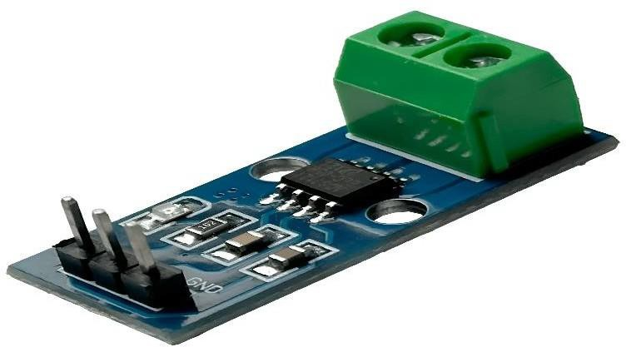

Figure 4.3 Current Sensor - ACS712-30A

    - DHT11 Sensor

The DHT11 sensor is an important environmental monitoring component used in the proposed transmission line fault detection system. It is designed to measure temperature and humidity levels in the surrounding environment of the transmission line. Environmental conditions play a significant role in the performance and reliability of power transmission systems. Variations in temperature and humidity can affect insulation, conductor properties, and overall system stability. By integrating the DHT11 sensor with the ESP32 microcontroller, the system is able to monitor environmental changes in real time and incorporate this information into the fault detection process. This enhances the system’s ability to identify potential risks that may not be directly related to electrical parameters.

Working Principle of DHT11 Sensor

The DHT11 sensor operates based on two main components: a thermistor for temperature measurement and a capacitive humidity sensor for detecting moisture levels in the air. The thermistor changes its resistance according to temperature variations, while the humidity sensor measures the change in capacitance caused by moisture in the environment. The sensor processes these changes internally and outputs the data as a calibrated digital signal. Unlike analog sensors, the DHT11 directly provides digital output, which simplifies interfacing with the ESP32. The communication between the DHT11 and the microcontroller is carried out using a single-wire protocol, where data is transmitted in a serial format.

Integration with ESP32 Microcontroller
The DHT11 sensor is connected to one of the digital input/output pins of the ESP32. The ESP32 uses a specific communication protocol to request and receive data from the sensor. The sensor sends temperature and humidity values in a structured digital format, which the ESP32 decodes and processes. The microcontroller continuously reads these values at regular intervals to ensure real-time monitoring. The data is then used for analysis and can also be displayed on the LCD or transmitted to IoT platforms. The simplicity of the DHT11 interface makes it easy to integrate into the system without requiring complex circuitry.

Role in Fault Detection and System Monitoring

Although the DHT11 does not directly measure electrical parameters, it plays a supportive role in fault detection. Environmental factors such as high temperature can lead to overheating of transmission lines, which may cause insulation failure or conductor damage. Similarly, high humidity levels can lead to moisture accumulation, increasing the risk of leakage currents or short circuits. By continuously monitoring these conditions, the system can detect situations that may lead to faults in the future. The ESP32 can be programmed to generate alerts if temperature or humidity exceeds safe limits, allowing preventive actions to be taken before a fault occurs.

Contribution to IoT-Based Monitoring

The data obtained from the DHT11 sensor is transmitted to IoT platforms through the ESP32’s Wi-Fi capability. This allows users to monitor environmental conditions remotely along with electrical parameters. The integration of environmental data provides a more comprehensive view of the system’s operating conditions. Users can analyse trends in

temperature and humidity over time and take preventive measures if necessary. This feature enhances the overall intelligence of the system and supports predictive maintenance strategies.

Advantages of Using DHT11 Sensor
The DHT11 sensor offers several advantages, including low cost, ease of integration, and reliable performance for basic environmental monitoring. It provides both temperature and humidity measurements in a single module, reducing the need for multiple sensors. The digital output eliminates the need for additional analog-to-digital conversion, simplifying the design. It is suitable for applications where moderate accuracy is sufficient and provides stable readings under normal operating conditions.

Limitations and Considerations

While the DHT11 is useful for basic monitoring, it has certain limitations such as limited accuracy and a narrow measurement range compared to advanced sensors. It may not be suitable for extreme environmental conditions. However, for this project, where general environmental monitoring is sufficient, the DHT11 serves as an effective and economical solution. Proper placement of the sensor is important to ensure accurate readings and avoid interference from external factors.

Conclusion of DHT11 Role
In conclusion, the DHT11 sensor enhances the proposed transmission line monitoring system by providing real-time information about environmental conditions. Its integration with the ESP32 allows continuous monitoring of temperature and humidity, which are important factors affecting system performance. Although it does not directly detect electrical faults, it contributes to preventive maintenance and improves overall system reliability. The inclusion of the DHT11 sensor makes the system more comprehensive and capable of handling both electrical and environmental monitoring requirements.

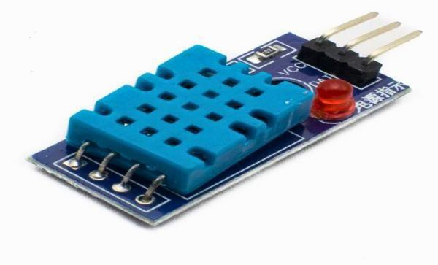

Figure 4.4 DHT11 sensor

ESP 32-CAM
The ESP32-CAM module is an advanced embedded camera system integrated into the proposed transmission line monitoring project to provide visual surveillance and real-time image acquisition. It is a compact and cost-effective module that combines an ESP32 microcontroller with a camera interface, enabling both image processing and wireless communication. The inclusion of the ESP32-CAM enhances the system by adding a visual monitoring layer, allowing operators to observe the physical condition of the transmission line remotely. This is particularly useful in detecting visible faults such as broken conductors, sparks, external obstructions, or environmental disturbances. By combining electrical parameter monitoring with visual inspection, the system becomes more intelligent and reliable.

Working Principle of ESP32-CAM
The ESP32-CAM operates by capturing images or video streams using an onboard camera sensor, typically the OV2640. The captured visual data is processed by the ESP32 processor integrated within the module. The module can compress and encode images into suitable formats such as JPEG before transmitting them over Wi-Fi. It supports both still image capture and continuous video streaming. The working principle involves capturing frames at defined intervals or triggering image capture based on specific events such as fault detection. The module can also be programmed to operate in different modes, including live streaming, periodic capture, or event-driven capture, depending on system requirements.

Integration with Main ESP32 System
In this project, the ESP32-CAM operates alongside the main ESP32 microcontroller. While the primary ESP32 handles sensor data processing and control operations, the ESP32- CAM is dedicated to visual monitoring tasks. Communication between the two modules can

be established through serial communication or coordinated through a common IoT platform. When the main ESP32 detects a fault condition, it can trigger the ESP32-CAM to capture an image or start video streaming. This coordinated operation ensures that visual evidence is available for every detected fault, improving the accuracy of diagnosis and decision-making.

Role in Fault Detection and Verification

The ESP32-CAM plays a significant role in enhancing fault detection by providing visual confirmation of abnormal conditions. While sensors can detect electrical and environmental anomalies, they may not always provide complete information about the physical state of the transmission line. The camera module fills this gap by allowing operators to visually inspect the system. For example, in the case of a detected voltage drop or current imbalance, the ESP32-CAM can capture images of the transmission line to identify possible causes such as physical damage or external interference. This reduces false alarms and helps in accurate fault classification.

IoT-Based Image Transmission and Remote Monitoring

One of the key features of the ESP32-CAM is its ability to transmit images and video over Wi-Fi. The module can upload captured images to a cloud server or web application, where they can be accessed remotely by users. This enables real-time monitoring of the transmission line from any location. The images can also be stored for future analysis and maintenance planning. The integration with IoT platforms allows seamless communication between the camera module and users, making the system more efficient and user-friendly. Alerts can also include image attachments, providing more detailed information about fault conditions.

Event-Based Monitoring and Automation

The ESP32-CAM can be programmed to operate based on specific events, such as fault detection, unusual environmental conditions, or scheduled intervals. This event-based monitoring reduces unnecessary data transmission and optimizes system performance. For instance, the camera can remain in standby mode during normal operation and activate only when a fault is detected. This approach conserves power and bandwidth while ensuring that critical events are captured and recorded. The automation capability of the ESP32-CAM makes it an intelligent addition to the system.

Advantages of Using ESP32-CAM

The ESP32-CAM offers several advantages in the proposed system. It provides real- time visual monitoring, enhancing fault detection accuracy. The module is compact, cost- effective, and easy to integrate with existing systems. Its built-in Wi-Fi capability eliminates the need for additional communication hardware. It supports both image and video transmission, making it versatile for different monitoring applications. The ability to operate in event-driven mode improves efficiency and reduces resource consumption.

Challenges and Considerations

Despite its advantages, the ESP32-CAM has certain limitations that need to be considered. It requires stable power supply and proper configuration to function reliably. The quality of images may be affected by environmental conditions such as lighting and weather. Additionally, continuous video streaming may consume significant bandwidth and power. Proper optimization and configuration are necessary to ensure efficient operation. Placement of the camera should also be carefully planned to capture relevant areas of the transmission line. In the ESP32-CAM module significantly enhances the proposed transmission line monitoring system by adding visual intelligence to the existing electrical and environmental monitoring framework. It enables real-time image capture, remote monitoring, and fault verification, making the system more comprehensive and reliable. By integrating visual data with sensor-based analysis, the ESP32-CAM improves fault diagnosis accuracy and supports faster decision-making. Its role in providing visual evidence and enabling smart monitoring makes it a valuable component in modern IoT-based power system applications.

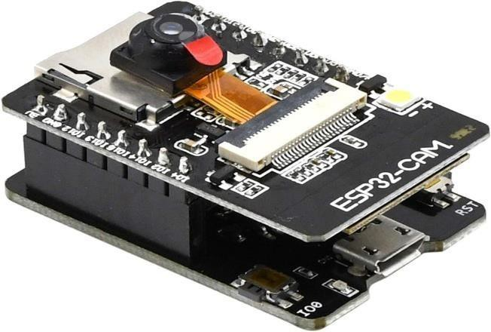

Figure 4.5 ESP32 CAM

MPU6050

The MPU6050 sensor is an advanced motion tracking device used in the proposed transmission line monitoring system to detect orientation, vibration, and movement-related changes. It is a combination of a 3-axis accelerometer and a 3-axis gyroscope integrated into a single chip, making it capable of measuring acceleration, tilt, rotation, and angular velocity. In this project, the MPU6050 is used to monitor physical disturbances in the transmission line such as tilting of poles, line vibrations, or sudden movements caused by environmental factors like wind, falling objects, or mechanical stress. These physical changes can indirectly indicate faults or potential risks in the transmission system. By integrating the MPU6050 with the ESP32 microcontroller, the system gains the ability to monitor not only electrical parameters but also mechanical conditions of the transmission infrastructure.

Working Principle of MPU6050

The MPU6050 operates using two sensing mechanisms: an accelerometer and a gyroscope. The accelerometer measures linear acceleration along three axes (X, Y, and Z), which helps in detecting tilt, motion, and vibration. It works based on changes in capacitance caused by movement. The gyroscope measures angular velocity, which helps in detecting rotation and orientation changes. It works based on the Coriolis effect, where rotating motion causes measurable displacement in a vibrating structure. The sensor combines these two sets of data to provide accurate motion tracking. The MPU6050 also includes a Digital Motion Processor (DMP), which can process raw sensor data and provide filtered outputs, reducing the computational load on the microcontroller.

Integration with ESP32 Microcontroller

The MPU6050 sensor communicates with the ESP32 microcontroller using the I2C (Inter-Integrated Circuit) communication protocol. It is connected through two main lines: Serial Data (SDA) and Serial Clock (SCL). The ESP32 acts as the master device and requests data from the MPU6050 at regular intervals. The sensor provides digital output data, including acceleration and angular velocity values for all three axes. The ESP32 processes this data to determine the orientation and movement of the transmission line structure. This integration allows real-time monitoring of physical conditions and ensures that any abnormal movement is detected immediately.

Role in Fault Detection and Structural Monitoring

The MPU6050 plays a crucial role in detecting physical disturbances that may not be captured by electrical sensors alone. For example, if a transmission pole tilts due to strong wind or structural weakness, the MPU6050 can detect the change in orientation. Similarly, unusual vibrations or sudden movements may indicate mechanical faults, loose connections, or external impacts. The ESP32 continuously analyses the data from the MPU6050 and compares it with predefined threshold values. If abnormal movement or tilt is detected, the system can generate alerts and take necessary actions. This enhances the overall fault detection capability by incorporating mechanical condition monitoring.

Data Processing and Decision Making
The raw data from the MPU6050 is processed by the ESP32 to calculate parameters such as tilt angle, acceleration magnitude, and rotational movement. The microcontroller uses algorithms to filter noise and extract meaningful information from the sensor data. Threshold values are set to identify normal and abnormal conditions. When the sensor data exceeds these thresholds, the system interprets it as a potential fault or disturbance. The ESP32 then triggers actions such as activating the buzzer, sending alerts through GSM, or updating the IoT platform. This intelligent processing ensures accurate detection and reduces false alarms.

Contribution to IoT Monitoring

The data obtained from the MPU6050 is transmitted to IoT platforms along with other sensor data. This allows remote monitoring of both electrical and mechanical conditions of the transmission line. Users can analyse movement patterns and identify potential risks before they lead to serious faults. The integration of motion data with other parameters provides a comprehensive view of the system’s health. This enhances predictive maintenance and improves system reliability.

Advantages of Using MPU6050
The MPU6050 offers several advantages, including high accuracy, compact size, and the ability to measure both acceleration and rotation. It provides real-time motion tracking, which is essential for detecting structural issues in transmission lines. The use of I2C communication simplifies integration with the ESP32. The built-in Digital Motion Processor reduces the processing burden on the microcontroller, improving system efficiency. It is also cost-effective and widely available, making it suitable for practical applications. In the

MPU6050 sensor enhances the proposed transmission line monitoring system by providing real-time information about physical movement and orientation. Its integration with the ESP32 allows the system to detect mechanical disturbances and structural issues effectively. By combining electrical and motion-based monitoring, the system becomes more robust and capable of identifying a wider range of faults. The MPU6050 plays a key role in improving the overall reliability, safety, and intelligence of the transmission line monitoring system.
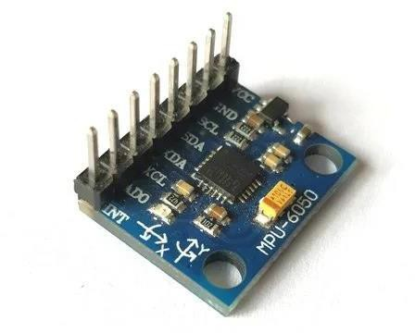

Figure 4.6 MPU6050 6-Axis Accelerometer & Gyroscope Sensor Module

    - Relay Module

The relay control module is a crucial component in the proposed transmission line monitoring system, responsible for controlling the power flow between the supply and the load. It acts as an electrically operated switch that enables the system to automatically connect or disconnect the transmission line based on fault conditions. In power systems, immediate isolation of faulty sections is essential to prevent equipment damage, reduce energy loss, and ensure safety. In this project, the relay module is controlled by the ESP32 microcontroller, which makes decisions based on sensor data. When a fault is detected, the relay is activated to cut off the power supply to the affected section, thereby protecting the system from further damage.

Working Principle of Relay

A relay operates based on the principle of electromagnetic induction. It consists of a coil, armature, and switching contacts. When a small electrical current flows through the coil, it generates a magnetic field that attracts the armature, causing the contacts to change their position. This allows a low-power control signal to switch a high-power circuit. In this system, the ESP32 provides a low-voltage control signal to the relay module, which then controls the

high-voltage AC supply connected to the transmission line. The relay can operate in normally open (NO) or normally closed (NC) configurations, depending on the design requirements.

Interfacing with ESP32 via Driver Circuit
Since the ESP32 operates at low voltage and cannot directly drive the relay coil, a driver circuit is used as an interface between the microcontroller and the relay. The driver circuit typically consists of a transistor and a flyback diode. The transistor amplifies the current from the ESP32 to a level sufficient to energize the relay coil. The flyback diode protects the circuit from voltage spikes generated when the relay coil is switched off. When the ESP32 sends a control signal, the driver circuit activates the relay, allowing it to switch the load. This setup ensures safe and efficient operation of the relay module.

Role in Fault Detection and Protection

The relay module plays a key role in the protection mechanism of the system. When the ESP32 detects abnormal conditions such as voltage fluctuations, current imbalance, or environmental risks, it immediately triggers the relay to disconnect the power supply. This prevents further damage to the transmission line and connected equipment. The relay ensures quick isolation of the faulty section, minimizing downtime and improving system reliability. Once the fault is cleared, the relay can be reset to restore normal operation. This automatic protection mechanism eliminates the need for manual intervention.

Automation and Control Logic

The operation of the relay is fully controlled by the ESP32 based on programmed logic. The microcontroller continuously monitors sensor data and compares it with predefined thresholds. If the values exceed safe limits, the ESP32 sends a signal to activate the relay. The system can also be programmed to implement delay mechanisms or confirmation checks to avoid false triggering. This intelligent control ensures that the relay operates only under genuine fault conditions. The automation improves system efficiency and ensures consistent performance.

Integration with IoT and Alert System
The relay control module is integrated with the IoT and communication system to provide real-time updates on its status. When the relay is activated, the ESP32 sends notifications through the GSM module and updates the IoT platform. Users can monitor

whether the load is connected or disconnected remotely. This feature enhances transparency and allows quick response from maintenance personnel. The system can also log relay operations for future analysis and maintenance planning.

Advantages of Using Relay Module

The relay module offers several advantages, including the ability to control high-power circuits using low-power signals, electrical isolation between control and load circuits, and reliable switching performance. It is cost-effective, easy to integrate, and suitable for both AC and DC applications. The relay provides a simple yet effective solution for implementing automatic protection mechanisms in power systems. In the relay control module is a vital component in the proposed system, enabling automatic isolation of faulty sections in the transmission line. Its integration with the ESP32 allows intelligent control based on real-time data analysis. By providing fast and reliable switching, the relay enhances system safety, reduces damage, and improves overall performance. The relay module plays a key role in ensuring that the system operates efficiently and responds effectively to fault conditions.

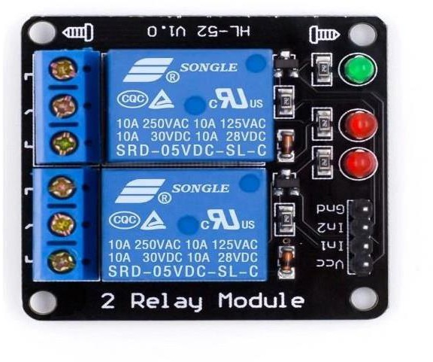

Figure 4.7 Relay Module
    - GSM Module

Introduction to GSM Module
The GSM module is an essential communication component in the proposed transmission line monitoring and fault detection system. It enables the system to send real-time alerts and notifications to authorized personnel whenever a fault or abnormal condition is

detected. GSM (Global System for Mobile Communication) technology allows wireless communication over cellular networks, making it highly reliable for long-distance data transmission. In this project, the GSM module is used to transmit SMS alerts containing information about the fault condition, location, and system status. This ensures that maintenance teams are informed immediately, even if they are far from the monitoring site, thereby reducing response time and improving system reliability.

Working Principle of GSM Module
The GSM module operates by communicating with cellular networks using a SIM card. It functions similarly to a mobile phone, allowing it to send and receive messages. The module communicates with the ESP32 microcontroller using serial communication (UART protocol). The ESP32 sends commands known as AT commands to the GSM module to perform operations such as sending SMS, making calls, or checking network status. When a fault is detected, the ESP32 sends specific AT commands to the GSM module, instructing it to send an SMS alert to predefined phone numbers. The GSM module then transmits this message through the cellular network to the intended recipients.

Integration with ESP32 Microcontroller
The GSM module is connected to the ESP32 using serial communication pins (TX and RX). The ESP32 acts as the controller and sends commands to the GSM module based on system conditions. The integration is designed in such a way that whenever the ESP32 detects a fault through sensor data, it immediately communicates with the GSM module to send an alert. The message content typically includes details such as voltage status, current imbalance, environmental conditions, and fault indication. This seamless integration ensures quick and efficient communication between the monitoring system and users.

Role in Fault Notification and Alert System

The GSM module plays a critical role in the fault notification process. When a fault occurs, immediate action is required to prevent further damage. The GSM module ensures that alerts are sent instantly to authorized personnel, enabling quick response and maintenance. Unlike IoT-based notifications that require internet connectivity, GSM-based alerts can work in areas with limited or no internet access, making it highly reliable. The system can be programmed to send different types of messages based on the severity of the fault, ensuring clear communication.

Real-Time Communication and Reliability

One of the key advantages of the GSM module is its ability to provide real-time communication over long distances. It does not depend on local network infrastructure and can operate wherever cellular coverage is available. This makes it suitable for remote transmission line monitoring applications. The GSM module ensures that alerts are delivered promptly, reducing the risk of delayed response. Its reliability and wide coverage make it an important component in the system.

Integration with IoT System

While the ESP32 provides IoT-based monitoring through Wi-Fi, the GSM module acts as a backup communication system. In case of internet failure or network issues, the GSM module ensures that critical alerts are still delivered. This dual communication approach increases the robustness of the system. The GSM module can also be used to receive commands from users, allowing remote control of the system if required.

Advantages of Using GSM Module

The GSM module offers several advantages, including wide network coverage, reliable communication, and independence from internet connectivity. It enables real-time alert transmission, ensuring quick response to faults. The module is easy to integrate with microcontrollers and supports simple command-based operation. It is cost-effective and suitable for both urban and rural applications.

Challenges and Considerations
Despite its advantages, the GSM module has certain limitations. It requires a valid SIM card and network coverage to operate effectively. Message delivery may be delayed in areas with poor signal strength. Additionally, there may be costs associated with sending SMS messages. Proper configuration and signal strength monitoring are necessary to ensure reliable operation.

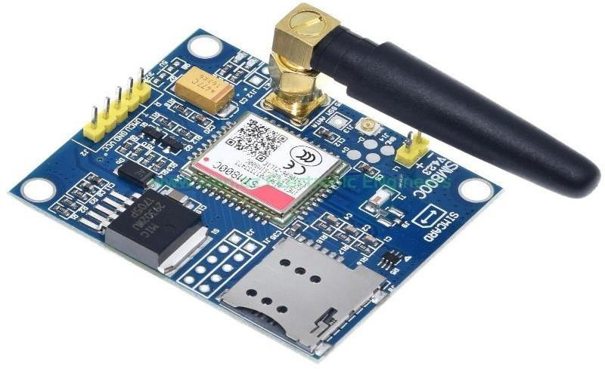

Figure 4.8 GSM Module
    - Wi-Fi (IoT Communication)

Introduction to Wi-Fi in IoT System

Wi-Fi communication plays a crucial role in transforming the proposed transmission line monitoring system into an IoT-enabled smart system. The ESP32 microcontroller used in this project comes with built-in Wi-Fi capability, which allows it to connect to wireless networks and communicate with cloud platforms or web servers. Through this connectivity, the system can transmit real-time data such as voltage, current, temperature, humidity, motion status, and fault conditions to remote users. Unlike traditional monitoring systems that require physical presence, Wi-Fi-based IoT communication enables users to access system data from anywhere, making the system more efficient, flexible, and intelligent.

Working Principle of Wi-Fi Communication

Wi-Fi communication operates based on wireless networking standards, allowing devices to exchange data over radio waves. In this system, the ESP32 connects to a local Wi- Fi network using credentials such as SSID and password. Once connected, it establishes communication with an IoT platform or cloud server using internet protocols such as HTTP or MQTT. The ESP32 collects sensor data, processes it, and sends it to the server at regular intervals or during specific events like fault detection. The server stores and displays this data through a web interface or mobile application, enabling users to monitor the system remotely. This real-time data transmission forms the backbone of IoT-based monitoring.

Integration with ESP32 Microcontroller

The ESP32 microcontroller has an integrated Wi-Fi module, eliminating the need for external communication hardware. The Wi-Fi functionality is programmed using embedded code, where the ESP32 is configured to connect to a specific network. Once connected, it continuously sends sensor data to the cloud and receives commands if required. The integration is seamless, allowing the ESP32 to handle both sensing and communication tasks simultaneously. This reduces system complexity and improves overall performance. The Wi- Fi module works in coordination with other components such as sensors, GSM module, and display units to provide a complete monitoring solution.

Role in Real-Time Monitoring
Wi-Fi enables real-time monitoring of the transmission line by continuously updating system parameters on a remote platform. Users can view live data such as voltage levels, current flow, environmental conditions, and fault status through a web dashboard or mobile application. This eliminates the need for manual inspection and allows operators to monitor multiple transmission lines simultaneously. In case of abnormal conditions, the system updates the status immediately, ensuring that users are aware of the situation without delay. This real- time capability significantly improves system efficiency and response time.

Data Transmission and Cloud Integration

The ESP32 uses Wi-Fi to send data to cloud platforms such as IoT dashboards or custom web servers. The data is transmitted in structured formats such as JSON or plain text, making it easy to store and analyse. Cloud integration allows data logging, visualization, and historical analysis. Users can track system performance over time, identify patterns, and take preventive measures. The cloud platform may also support features such as data analytics, alerts, and remote control, enhancing the functionality of the system.

Remote Control and Automation
In addition to monitoring, Wi-Fi communication enables remote control of the system. Users can send commands from a web interface or mobile app to control devices such as relays. For example, the system can be programmed to allow remote resetting of the relay after a fault is cleared. This reduces the need for physical intervention and improves operational efficiency. Automation features can also be implemented, where the system responds automatically to certain conditions without user input.

Advantages of Wi-Fi in the System

The use of Wi-Fi offers several advantages, including high-speed data transmission, real-time monitoring, and remote accessibility. It eliminates the need for wired communication, reducing installation complexity. The built-in Wi-Fi capability of the ESP32 reduces hardware cost and simplifies design. It supports integration with various IoT platforms, making the system scalable and adaptable to future enhancements. Wi-Fi also enables continuous data logging and analysis, which is essential for predictive maintenance.
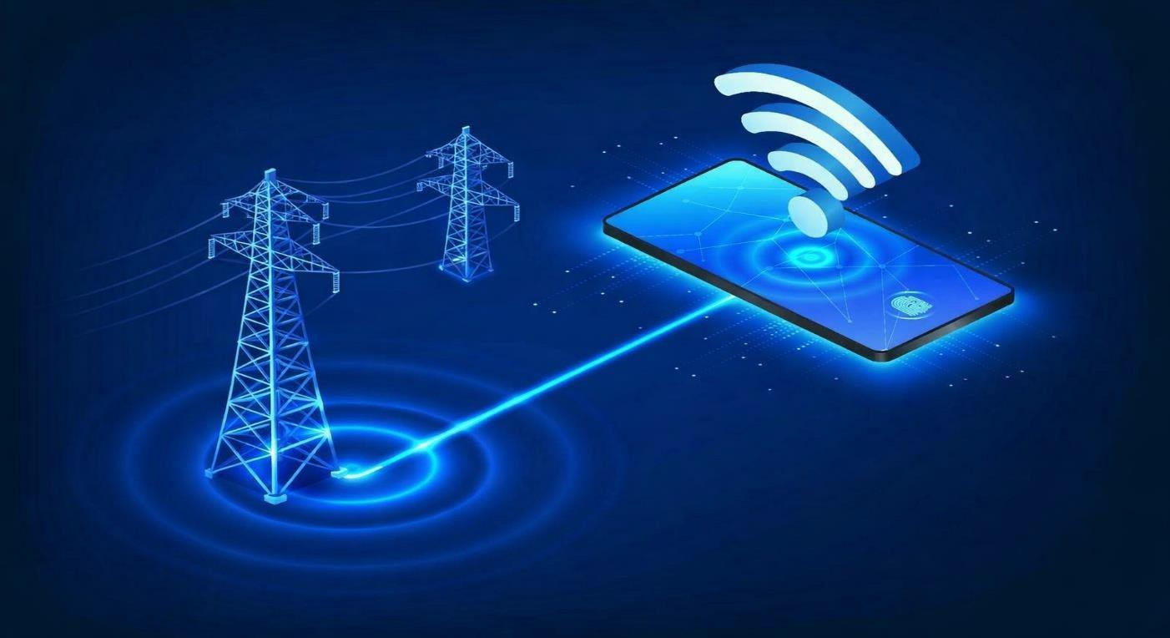

Figure 4.9 Wi-Fi

    - LCD Display with I2C Module Interface

The LCD (Liquid Crystal Display) is an important output component in the proposed transmission line monitoring and fault detection system. It is used to display real-time information about system parameters such as voltage, current, temperature, humidity, fault status, and system messages. The LCD provides a user-friendly interface that allows operators to monitor the system locally without the need for external devices like computers or mobile phones. In this project, the LCD acts as a visual communication medium between the system and the user, ensuring that all critical information is readily available at the monitoring site. Its integration enhances the usability and effectiveness of the system by providing immediate feedback.

Working Principle of LCD

The LCD operates based on the properties of liquid crystals, which can change their alignment when an electric field is applied. This change in alignment affects the passage of light through the display, allowing characters and symbols to be formed on the screen. The LCD used in embedded systems is typically a character-based display, such as a 16x2 or 20x4 LCD, which can display a fixed number of characters per line. It requires a controller to send commands and data for displaying text. The display is controlled by sending specific instructions that determine what characters should appear and where they should be positioned on the screen.

Interfacing with ESP32 Microcontroller
The LCD is interfaced with the ESP32 microcontroller either through parallel communication or using an I2C module. In this project, an I2C-based LCD is commonly used to reduce the number of required connection pins. The ESP32 sends data to the LCD through the I2C communication protocol using two lines: SDA (data) and SCL (clock). The microcontroller processes sensor data and converts it into readable text, which is then displayed on the LCD. The display is updated continuously to reflect real-time changes in system parameters. This integration ensures efficient communication between the processing unit and the display module.

Role in Real-Time Monitoring
The LCD plays a key role in providing real-time monitoring of system parameters. It displays values such as voltage levels, input and output current, temperature, humidity, and system status. When the system is operating normally, the LCD shows stable readings and system health status. In case of a fault, the display updates immediately to show fault messages such as “Voltage Fault,” “Current Imbalance,” or “System Alert.” This allows operators to quickly identify issues without needing to access remote monitoring platforms. The LCD ensures that critical information is always visible at the system location.

Display of Fault Conditions and Alerts

One of the most important functions of the LCD is to display fault conditions clearly. When the ESP32 detects a fault based on sensor data, it sends specific messages to the LCD to inform the user. These messages may include the type of fault, affected parameter, and system response such as relay activation. The LCD may also display warning messages when

parameters approach unsafe limits. This early warning system helps operators take preventive actions before a major fault occurs. The combination of visual display and buzzer alerts enhances the effectiveness of the system.

Integration with Other Components

The LCD works in coordination with other components such as sensors, relay module, GSM module, and buzzer. While the sensors provide input data and the ESP32 processes it, the LCD presents the processed information in a readable format. At the same time, the GSM module sends alerts to remote users, and the buzzer provides audible alerts. This coordinated operation ensures that the system provides both local and remote monitoring capabilities. The LCD serves as the primary local interface, making the system more interactive and user- friendly.

Advantages of Using LCD Display
The LCD display offers several advantages, including low power consumption, clear visibility, and ease of integration. It provides real-time information without requiring internet connectivity, making it reliable for on-site monitoring. The display is cost-effective and widely available, making it suitable for embedded system applications. It also supports multiple languages and custom messages, allowing flexibility in design.

Challenges and Considerations
While the LCD is highly useful, it has certain limitations such as limited display size and character capacity. It cannot display complex graphics or large amounts of data. Proper contrast adjustment is required for clear visibility under different lighting conditions. Additionally, the display should be protected from environmental factors such as dust and moisture to ensure long-term reliability.

Conclusion of LCD Role
In conclusion, the LCD display is an essential component that provides real-time visual feedback in the proposed transmission line monitoring system. It enables local monitoring of system parameters and fault conditions, improving user interaction and system usability. Its integration with the ESP32 ensures accurate and timely display of information. By providing clear and immediate feedback, the LCD enhances the effectiveness, reliability, and user- friendliness of the overall system.

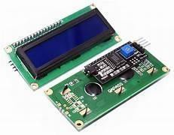

Figure 4.10 LCD with I2C Module

    - Buzzer
The buzzer is an important alerting component in the proposed transmission line monitoring and fault detection system. It is used to provide an audible indication whenever a fault or abnormal condition is detected. In many real-time monitoring systems, visual indicators alone may not be sufficient, especially when operators are not continuously observing the display. The buzzer ensures that immediate attention is drawn to critical events by generating sound alerts. In this project, the buzzer works in coordination with the ESP32 microcontroller and is activated automatically when fault conditions such as voltage variation, current imbalance, or abnormal environmental conditions are detected.

Working Principle of Buzzer
A buzzer is an electronic device that converts electrical signals into sound. It typically consists of a piezoelectric element that vibrates when an electric voltage is applied, producing sound waves. There are two types of buzzers: active and passive. In this system, an active buzzer is commonly used, which generates sound when powered without requiring additional signal modulation. When the ESP32 sends a control signal, the buzzer is energized and produces a continuous or intermittent sound depending on the programming. The frequency and duration of the sound can be controlled to indicate different types of alerts.

Interfacing with ESP32 Microcontroller

The buzzer is connected to one of the digital output pins of the ESP32. The microcontroller controls the buzzer by sending HIGH or LOW signals. When a HIGH signal is applied, the buzzer is activated and produces sound, and when a LOW signal is applied, it stops. The ESP32 is programmed to trigger the buzzer when certain conditions are met, such as when

sensor values exceed predefined thresholds. The control logic can also include patterns such as beeping intervals or continuous sound to differentiate between warning and critical fault conditions.

Role in Fault Indication

The buzzer plays a key role in providing immediate fault indication. When the system detects a fault, the ESP32 activates the buzzer instantly, alerting nearby personnel. This is especially useful in situations where the operator is not looking at the LCD display or remote monitoring system. The buzzer ensures that faults are not overlooked and that quick action can be taken. It acts as a first-level alert system, providing real-time notification of abnormal conditions.

Integration with Alert and Monitoring System

The buzzer works in coordination with other components such as the LCD display, GSM module, and IoT system. While the LCD provides visual information and the GSM module sends remote alerts, the buzzer provides local audible alerts. This multi-level alert system ensures that fault conditions are communicated effectively through different channels. The ESP32 synchronizes all these components, ensuring that the buzzer is activated simultaneously with other alert mechanisms.

Programmable Alert Patterns
One of the advantages of using a buzzer is the ability to program different alert patterns. For example, a short beep may indicate a warning condition, while a continuous sound may indicate a critical fault. This helps users quickly understand the severity of the issue without checking the display. The ESP32 can be programmed to generate these patterns based on sensor data, making the alert system more intelligent and informative.

Advantages of Using Buzzer
The buzzer offers several advantages, including low cost, simple operation, and immediate response. It consumes very little power and can be easily integrated with microcontrollers. The audible alert ensures that faults are noticed even in noisy or busy environments. It enhances the safety and responsiveness of the system by providing instant feedback.

Challenges and Considerations

Despite its usefulness, the buzzer has some limitations. Continuous sound may become annoying or may be ignored over time if not properly managed. Therefore, it is important to design appropriate alert patterns and durations. The sound level should be sufficient to be heard but not excessively loud. Proper placement of the buzzer is also important to ensure effective sound distribution.

Conclusion of Buzzer Role

In conclusion, the buzzer is a simple yet effective component that enhances the alerting capability of the proposed transmission line monitoring system. It provides immediate audible notification of faults, ensuring that operators can respond quickly. Its integration with the ESP32 allows automated and intelligent control based on real-time data. By complementing visual and remote alerts, the buzzer improves the overall reliability, safety, and effectiveness of the system.
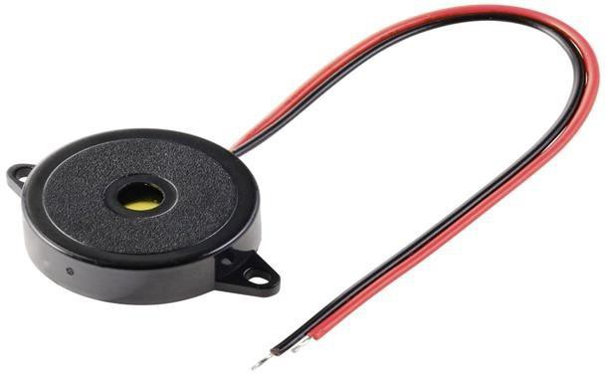

Figure 4.11 Buzzer

    - Power Supply Unit

The power supply unit is one of the most fundamental components in the proposed transmission line monitoring and fault detection system, as it provides the necessary electrical energy required for the operation of all electronic modules. Every component in the system, including the ESP32 microcontroller, sensors, relay module, GSM module, LCD display, and buzzer, requires a stable and regulated DC power source to function correctly. Since the available input is typically an AC 230V supply, it must be converted into suitable low-voltage DC levels. The power supply unit performs this conversion and ensures that all components receive consistent and safe voltage levels for reliable operation.

Working Principle of Power Supply Unit

The power supply unit works by converting high-voltage AC input into low-voltage DC output through a series of stages. The first stage involves a step-down transformer, which reduces the high AC voltage to a lower level. This is followed by a rectifier circuit, usually made up of diodes, which converts AC into pulsating DC. The next stage involves filtering, where capacitors are used to smooth out the ripples in the DC signal. Finally, a voltage regulator is used to maintain a constant output voltage regardless of variations in input or load conditions. The output is a stable DC voltage that can safely power the microcontroller and other components.

Types of Power Supply in the System
In this project, multiple voltage levels may be required for different components. For example, the ESP32 typically operates at 3.3V, while other modules like relays and LCDs may require 5V. The power supply unit is designed to provide these different voltage levels using voltage regulators or DC-DC converters. This ensures that each component receives the correct voltage according to its specifications. Proper voltage distribution is essential to avoid malfunction or damage to components.

Integration with System Components

The power supply unit is connected to all components in the system, acting as a central energy source. It provides regulated power to the ESP32, which in turn powers and controls other modules. Sensors such as voltage sensors, current sensors, DHT11, and MPU6050 rely on the power supply for accurate operation. The relay module requires sufficient power to switch loads, while communication modules like GSM and Wi-Fi depend on stable voltage for reliable data transmission. The LCD and buzzer also require consistent power for proper display and alert functions. Any fluctuation in power supply can affect the performance of the entire system, making this unit critically important.

Role in System Stability and Reliability

The power supply unit plays a key role in ensuring system stability and reliability. A stable power supply prevents unexpected resets, incorrect sensor readings, and communication failures. It ensures that all components operate within their specified voltage range, reducing the risk of damage. In fault detection systems, reliability is crucial, as incorrect operation can

lead to missed faults or false alarms. The power supply unit ensures continuous and uninterrupted operation, which is essential for real-time monitoring systems.

Protection Mechanisms in Power Supply
To ensure safety, the power supply unit may include protection mechanisms such as overvoltage protection, overcurrent protection, and short-circuit protection. These features prevent damage to components in case of abnormal conditions. Fuses or circuit breakers may also be included to disconnect the system in case of severe faults. Proper insulation and grounding are maintained to ensure safe operation, especially when dealing with high-voltage AC input.

Advantages of Using Regulated Power Supply

The use of a regulated power supply provides several advantages, including stable output voltage, improved system performance, and increased component lifespan. It reduces noise and fluctuations in the power signal, ensuring accurate sensor readings and reliable communication. A well-designed power supply improves the overall efficiency and robustness of the system.

Challenges and Considerations

Designing an efficient power supply requires careful consideration of factors such as voltage levels, current requirements, heat dissipation, and efficiency. Improper design can lead to overheating, voltage drops, or unstable operation. It is important to select appropriate components such as transformers, regulators, and capacitors. Proper heat management and ventilation should also be ensured to maintain long-term reliability.

Conclusion of Power Supply Role

In conclusion, the power supply unit is the backbone of the proposed transmission line monitoring system, providing the necessary energy for all components to function effectively. Its role in converting and regulating voltage ensures safe and reliable operation of the system. By maintaining stable power conditions, it enhances system performance, accuracy, and longevity. The power supply unit is essential for ensuring that the entire system operates efficiently and responds correctly to fault conditions.

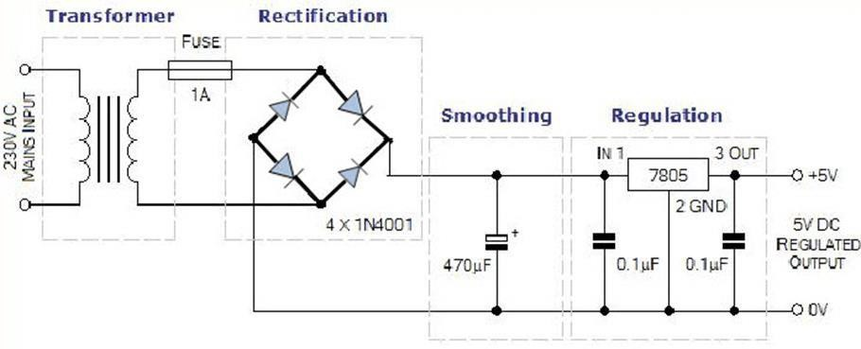

5V Power Supply Figure 4.12 Power Supply Unit
    - Step Down Transformer

The step-down transformer is a crucial component in the power supply unit of the transmission line monitoring and fault detection system. Its primary function is to reduce the high-voltage AC input (230V) to a lower and safer voltage level (9V AC) suitable for electronic circuits. This voltage reduction is essential because microcontrollers and sensors cannot operate directly on high-voltage supply. The transformer operates based on the principle of electromagnetic induction. It consists of two windings: the primary winding connected to the input supply and the secondary winding connected to the output. When alternating current flows through the primary winding, it creates a varying magnetic field, which induces a lower voltage in the secondary winding based on the turns ratio. In this system, the 230V AC input is stepped down to 9V AC, which is then passed to a rectifier circuit to convert it into DC. This DC voltage is further filtered and regulated to provide stable power to components like the ESP32, sensors, LCD, and buzzer. The transformer provides electrical isolation between high- voltage and low-voltage sections, improving safety. It ensures reliable voltage conversion, making it a fundamental part of the system’s power supply design and overall operation

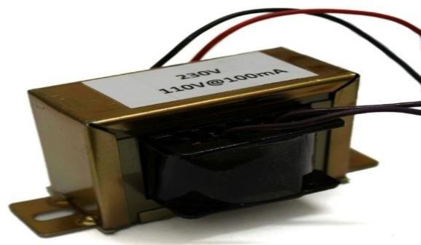

Figure 4.13 Stepdown transformer
    - Potentiometer

The potentiometer is an important adjustable component used in the transmission line monitoring and fault detection system. It is a type of variable resistor that allows the user to manually control or adjust electrical parameters such as voltage levels. In this project, the potentiometer is mainly used for adjusting the contrast of the LCD display or for fine-tuning input signals during system calibration. A potentiometer consists of three terminals: two fixed ends and one movable wiper. By rotating the knob, the position of the wiper changes, which varies the resistance between the terminals. This variation in resistance results in a change in output voltage, which can be used to control different aspects of the system. When connected to the LCD, the potentiometer helps in adjusting the display contrast, ensuring that the characters are clearly visible under different lighting conditions. Without proper contrast adjustment, the display may appear too dim or too dark, making it difficult to read. The potentiometer is simple to use, cost-effective, and easy to integrate into electronic circuits. It provides flexibility during testing and calibration of the system. Overall, it enhances user control and improves the readability and performance of the system, making it a useful supporting component.
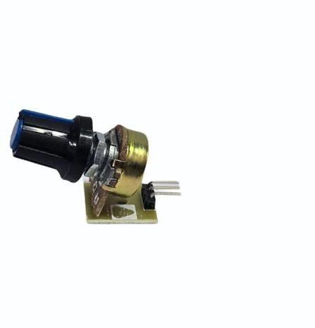

Figure 4.14 Potentiometer

    - Buck Converter

The buck converter is an essential power management component used in the transmission line monitoring and fault detection system. Its primary function is to step down a higher DC voltage to a lower DC voltage efficiently, making it suitable for powering low- voltage electronic components such as the ESP32, sensors, LCD, and communication modules. A buck converter operates using a switching mechanism that rapidly turns a transistor on and off. It consists of key components such as an inductor, diode, capacitor, and switching element. When the switch is ON, energy is stored in the inductor, and when it is OFF, the stored energy is released to the load, resulting in a reduced and regulated output voltage. This process ensures high efficiency compared to linear regulators, as it minimizes power loss in the form of heat. In this system, the buck converter is used to convert higher DC voltage levels obtained after rectification into stable lower voltages like 5V or 3.3V required by different components. Many buck converter modules also include a potentiometer to adjust the output voltage as needed. The buck converter improves energy efficiency, reduces heat generation, and ensures stable power delivery. Its compact size, reliability, and efficiency make it a crucial component in modern embedded systems and power supply design.
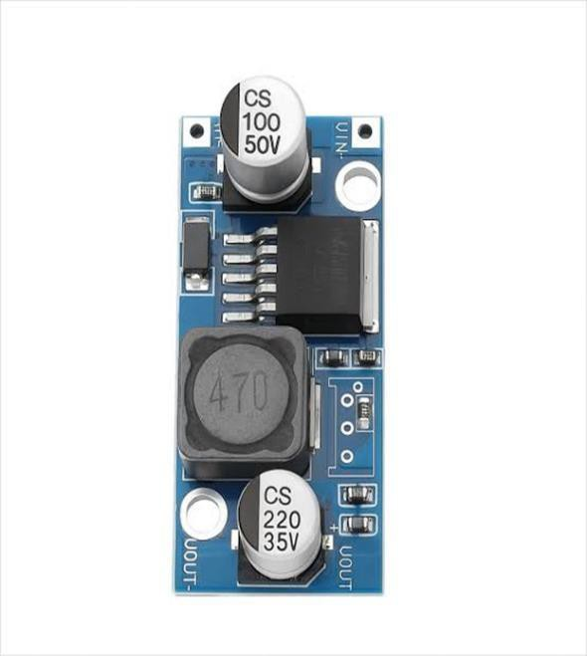

Figure 4.15 Buck Converter

- Software Specification

- Arduino IDE
The Arduino Integrated Development Environment (IDE) is a powerful, open-source software tool used for writing, editing, compiling, and uploading code to Arduino and other compatible microcontroller boards. It acts as the main platform where users develop and test programs known as sketches. The Arduino IDE uses a simplified version of C++ programming language, making it accessible for beginners while still powerful enough for advanced users. It features a text editor for writing code, a verify button to check the code for errors, an upload button to transfer the code to the hardware, and a built-in Serial Monitor for communication with the microcontroller during runtime.
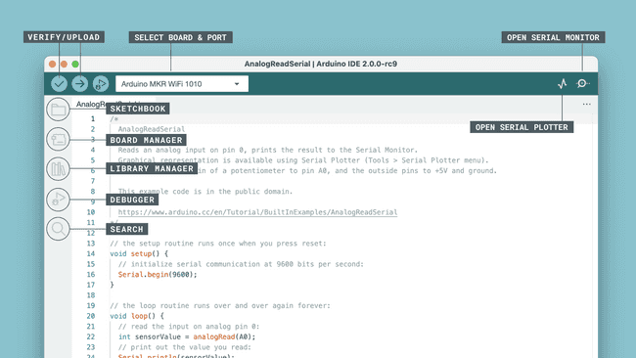

Figure 4.16 Arduino IDE

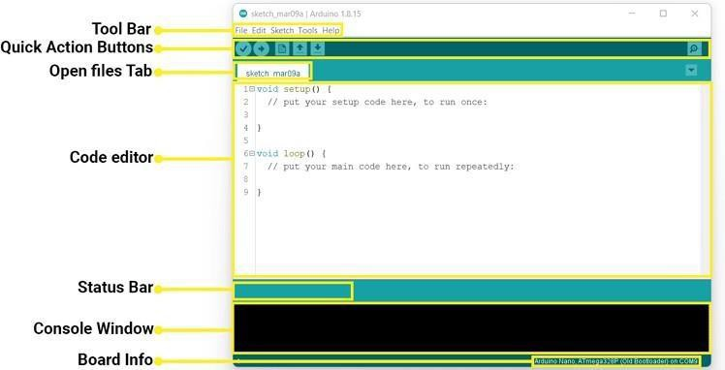

Figure 4.17 Arduino IDE display in detail

The IDE supports a wide range of microcontrollers, including not only Arduino boards but also ESP32, ESP8266, STM32, and more through the addition of board support packages. Users can easily install libraries from the Library Manager to add functionalities like sensor interfacing, motor control, IoT communication, and data processing. It is available for Windows, macOS, and Linux operating systems. The Arduino IDE promotes rapid prototyping by allowing easy integration of hardware and software components. With continuous updates, strong community support, and a vast collection of online tutorials and examples, Arduino IDE remains a fundamental tool for electronics projects, especially in robotics, automation, and Internet of Things (IoT) applications.

4.2.2 Proteus Software

Proteus Design Suite is a widely used Electronic Design Automation (EDA) software for designing, simulating, and validating electronic circuits. In this project, Proteus is used to create and test the complete circuit in a virtual environment before implementing it in hardware. The software, developed by Labcenter Electronics, provides an efficient platform for analyzing both analog and digital circuits in real time. It allows the integration of microcontrollers, sensors, and other electronic components, making it highly suitable for embedded and IoT-

based applications.In the proposed system, Proteus is utilized to design the circuit diagram, simulate the working of components, and verify the output responses such as relay operation, voltage variations, and sensor outputs. The software includes two main modules: ISIS, which is used for schematic design and simulation, and ARES, which is used for PCB layout design. Through simulation, errors can be identified and corrected at an early stage, thereby reducing development cost and improving system efficiency.The use of Proteus in this project offers several advantages such as minimizing hardware dependency, saving time, and enabling easy modification of the circuit design. It also provides a user-friendly interface and a wide range of component libraries for efficient design. However, certain real-time conditions may not be fully replicated in simulation, and some advanced IoT modules may have limited support. Overall, Proteus Design Suite plays a vital role in ensuring accurate design, testing, and validation of the system, thereby enhancing the reliability and performance of the project.
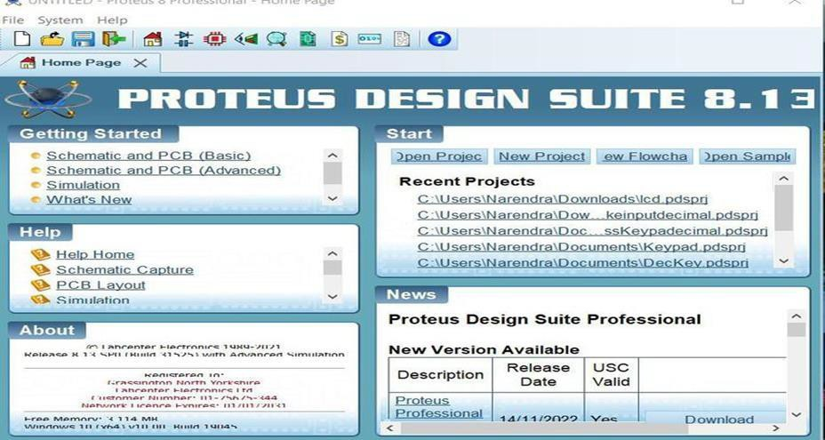

Figure 4.18 Proteus Software

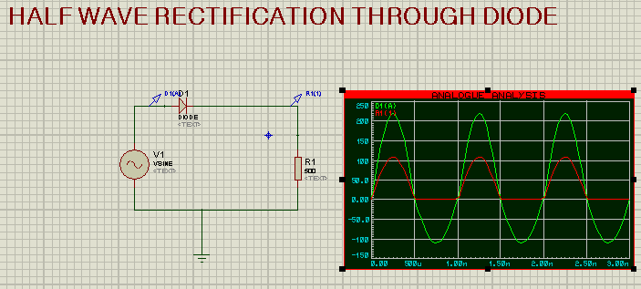

Figure 4.19 Circuit simulation using Proteus Design Suite
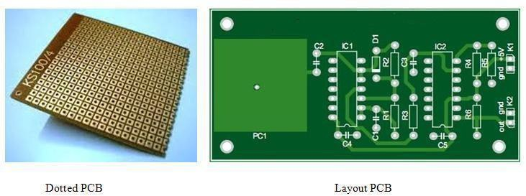

Figure 4.20 PCB layout designed in Proteus ARES module

64

4.2.3 ThingSpeak IoT Platform
ThingSpeak is an open-source IoT analytics platform used for collecting, storing, analyzing, and visualizing real-time data from connected devices. In this project, ThingSpeak is utilized to monitor and display sensor data such as voltage, current, temperature, humidity, and other parameters through graphical representation. The platform, developed by MathWorks, enables seamless communication between hardware devices and cloud services using APIs and internet connectivity.In the proposed system, data obtained from sensors and microcontrollers is transmitted to the ThingSpeak cloud using Wi-Fi modules such as ESP32. The received data is then processed and displayed in the form of multiple graphs, allowing users to analyze system performance remotely. ThingSpeak also supports MATLAB integration, which helps in performing advanced data analysis, filtering, and real-time decision- making.The use of ThingSpeak in this project provides several advantages such as remote monitoring, real-time data visualization, and easy data storage. It reduces the need for manual data collection and enables users to access system parameters from anywhere. However, it requires a stable internet connection for continuous data transmission, and there may be limitations in data update intervals in the free version. Overall, ThingSpeak serves as an effective cloud platform for IoT-based applications, improving system monitoring, analysis, and efficiency.
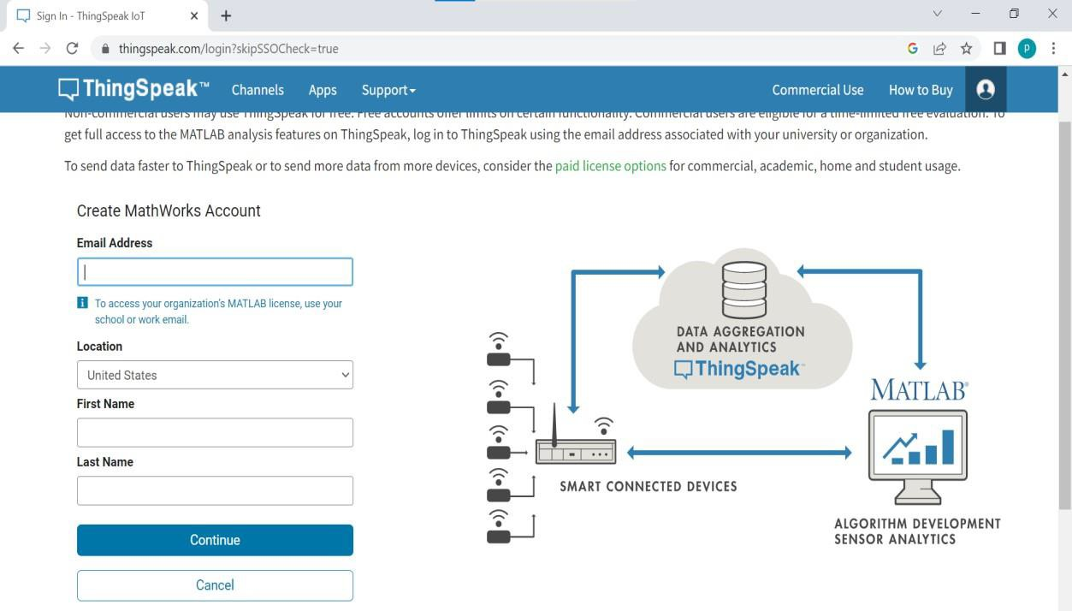

Figure 4.21 Thingspeak
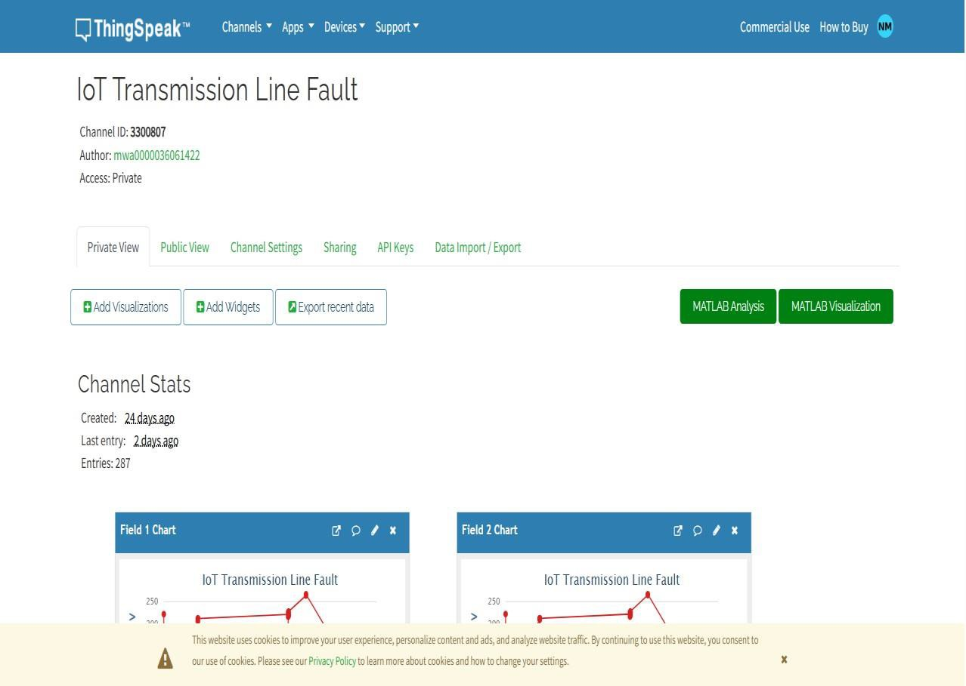

Figure 4.22 ThingSpeak Analytics

CHAPTER 5

SYSTEM IMPLEMENTATION

  - Circuit Diagram
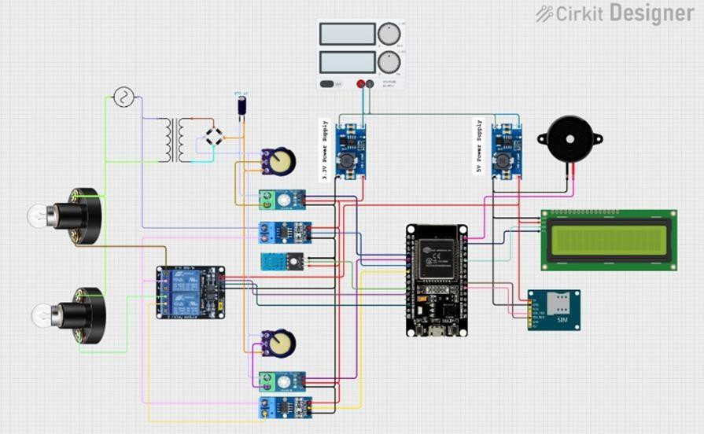

Figure 5.1 Circuit Diagram

  - Circuit Description
The given circuit diagram represents an IoT-based transmission line monitoring and fault detection system built around the ESP32 microcontroller. The system integrates power supply, sensing units, control circuits, communication modules, and output devices into a single platform for efficient monitoring and protection of electrical loads. The circuit begins with an AC power source, which is stepped down using a transformer and then rectified through a bridge rectifier to convert AC into DC. This DC voltage is filtered using a capacitor and regulated to provide a stable power supply for the ESP32 and other low-voltage components. This section ensures safe operation by isolating high-voltage input from sensitive electronic circuits.
The voltage sensing and current sensing sections form the core of the monitoring system. Voltage sensors are connected across the supply line to measure the voltage level, while current sensors are placed in series with the load to measure input and output current. These sensors provide analog signals proportional to the electrical parameters, which are then fed into

the ESP32’s analog input pins. By continuously comparing input and output current values, the system can detect abnormalities such as leakage currents, overload conditions, or short circuits. This real-time sensing mechanism enables accurate fault identification and quick response.
The ESP32 microcontroller acts as the central processing unit of the entire circuit. It collects data from all sensors, processes it using programmed logic, and controls various output components. Based on the sensor readings, the ESP32 determines whether the system is operating under normal or faulty conditions. If a fault is detected, it sends a control signal to the relay module through a driver interface. The relay module is connected to the load and functions as a switch to disconnect the power supply during fault conditions. This helps in protecting electrical equipment and preventing further damage.
In addition to electrical monitoring, the circuit includes environmental sensors such as the DHT11 for temperature and humidity measurement. These sensors are connected to the ESP32 and provide additional data that can influence system performance. For example, high temperature may indicate overheating, which can lead to faults. The MPU6050 sensor is also integrated to detect vibration or movement, which may signal physical disturbances in the transmission line. These additional sensing capabilities enhance the system’s reliability and allow for more comprehensive monitoring.
The circuit also incorporates communication modules for real-time data transmission. A GSM module is connected to the ESP32 to send alert messages when faults occur, ensuring that users are immediately notified. Additionally, the ESP32 uses its built-in Wi-Fi capability to connect to an IoT platform, enabling remote monitoring of system parameters. Users can access real-time data such as voltage, current, and environmental conditions from anywhere. This feature greatly improves system accessibility and reduces the need for manual inspection.
For user interaction and alerting, the circuit includes an LCD display and a buzzer. The LCD is used to display real-time system parameters and fault status, allowing local monitoring. The buzzer provides an audible alert when a fault is detected, ensuring immediate attention even without visual monitoring. Furthermore, the circuit includes adjustable components such as potentiometers, which are used to calibrate sensor readings and set threshold values for fault detection.

  - Hardware Implementation
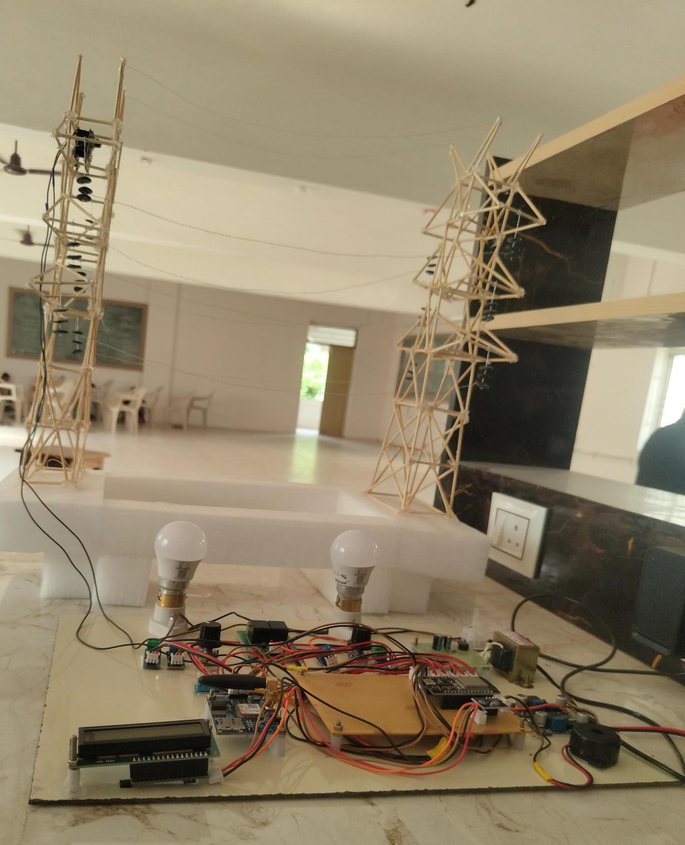

Figure 5.2 Hardware Connection setup

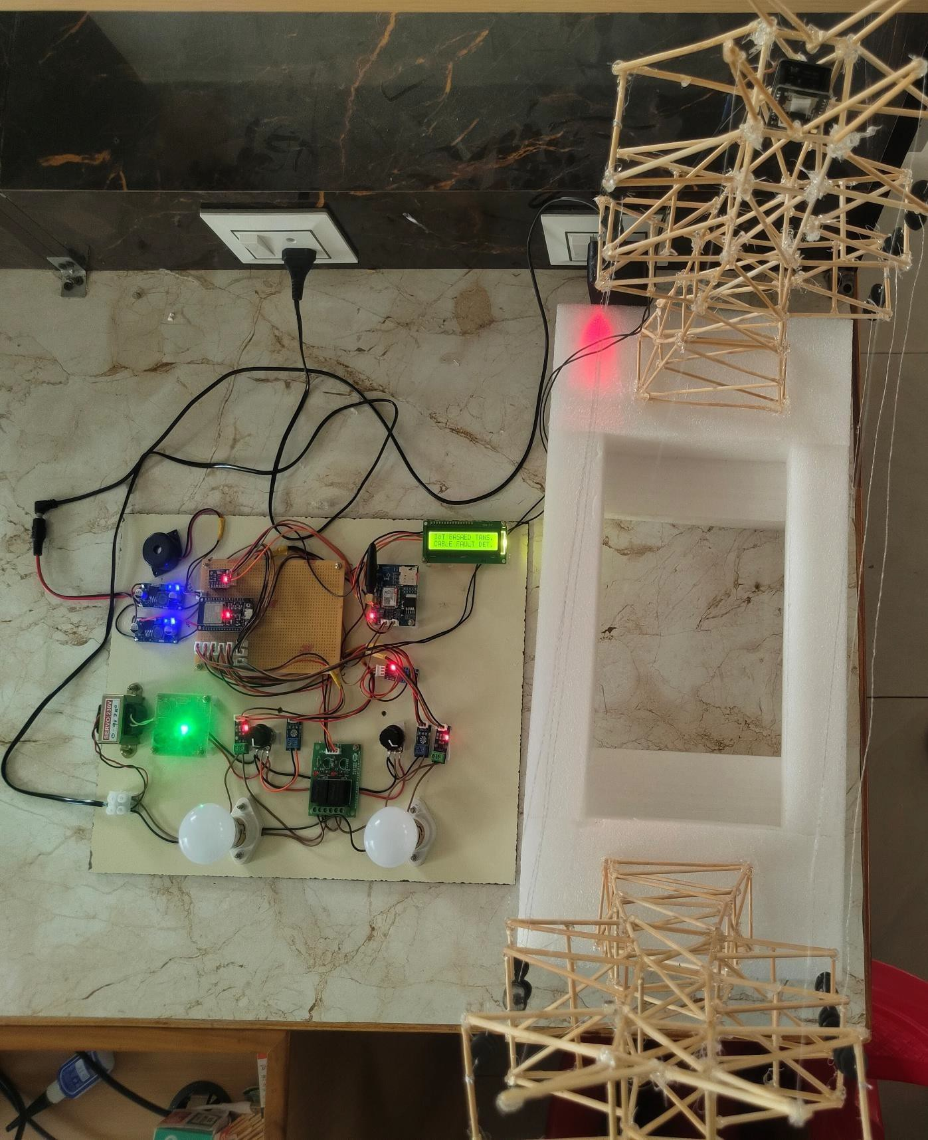

Figure 5.3 Complete Hardware Implementation of Transmission Line Fault Detection System

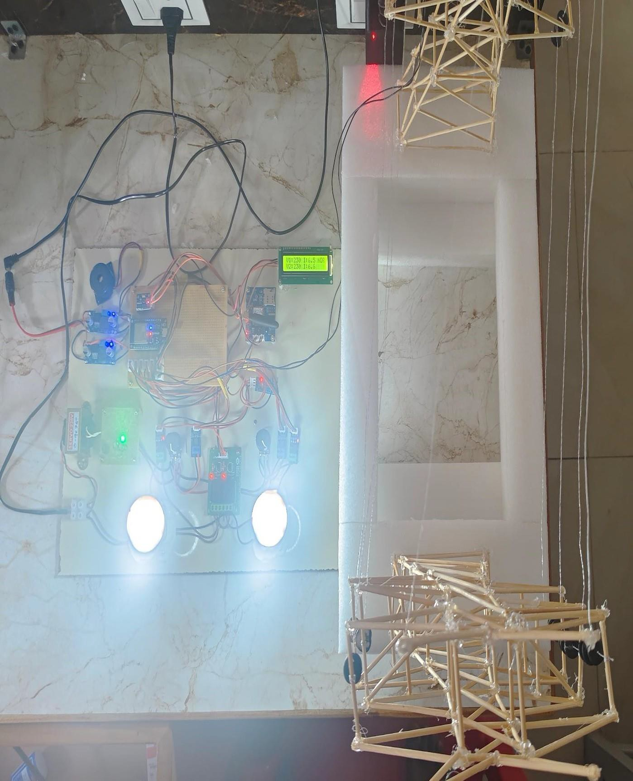

Figure 5.4 Fault-Free Operation of the System

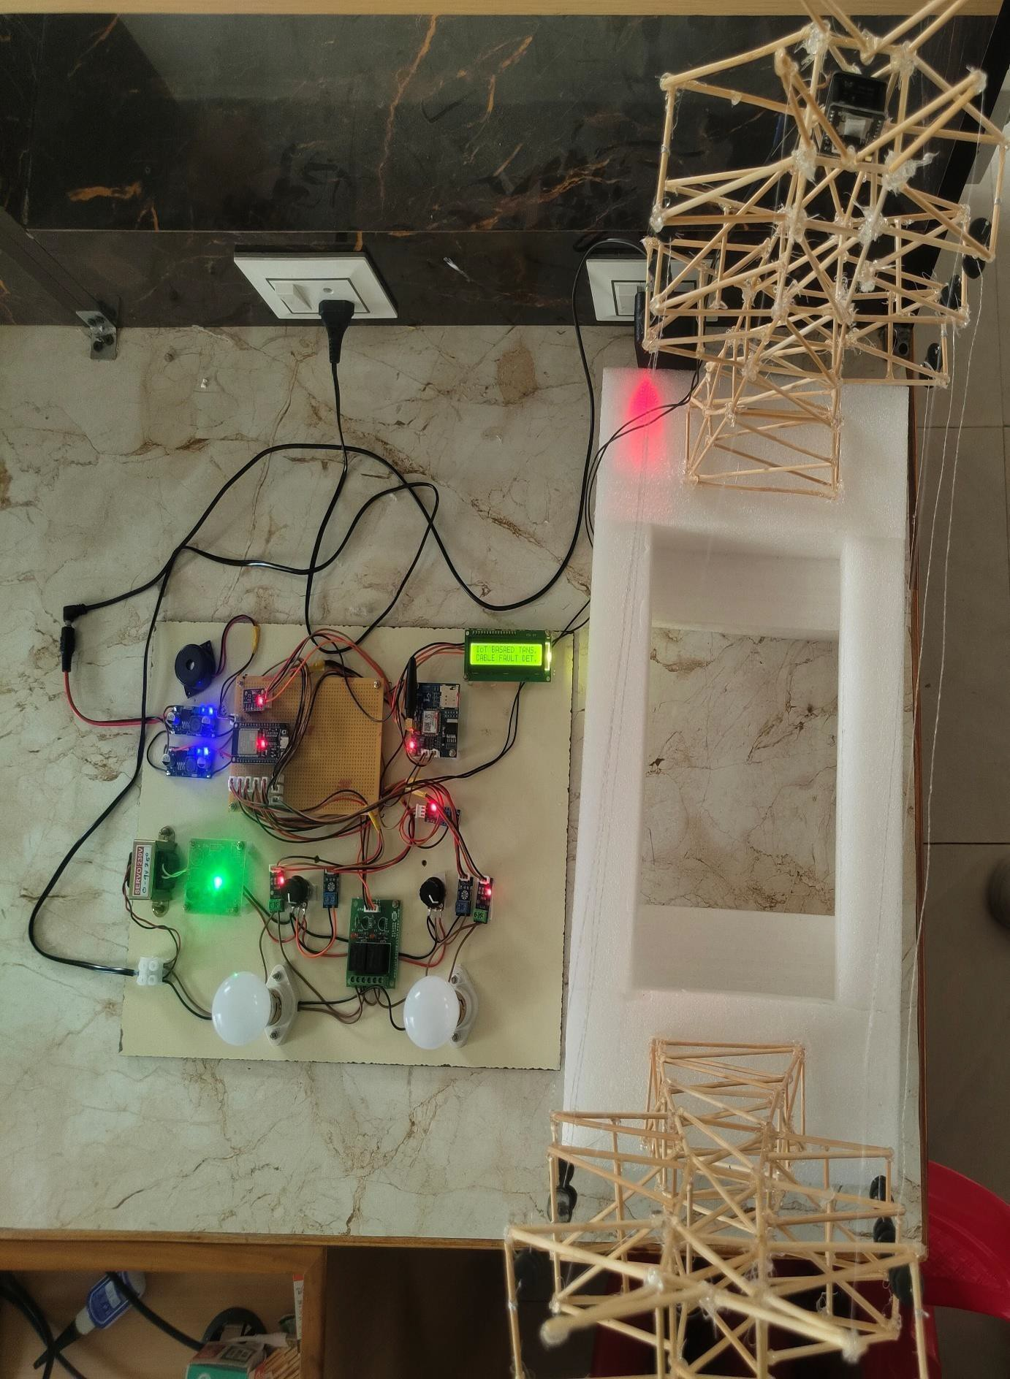

Figure 5.5 Generation Side Fault Detection output

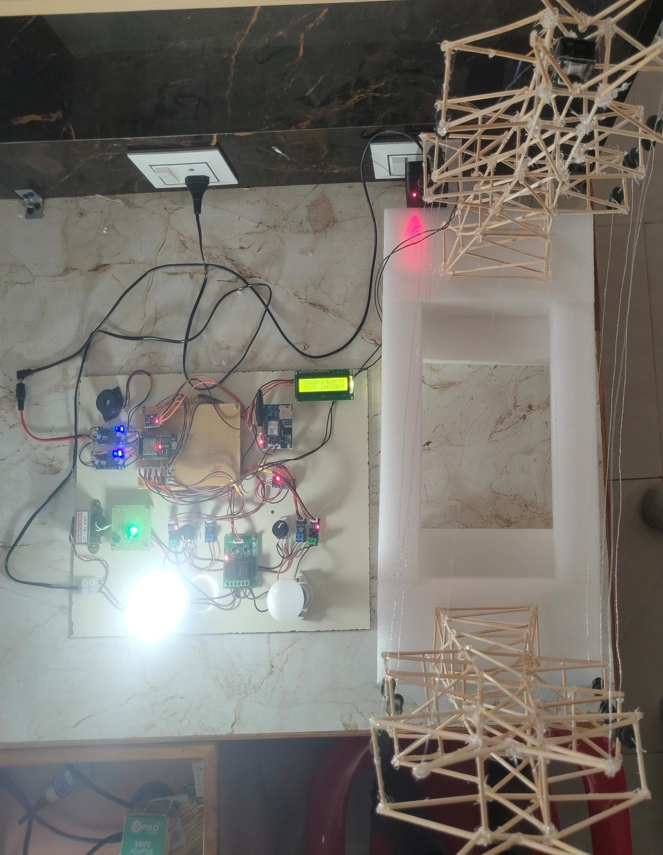

Figure 5.6 Distribution Side Fault Detection System

The above figures represent the real-time hardware implementation of the proposed IoT-based transmission line monitoring and fault detection system. The system was tested under various conditions including normal operation, generation side fault, and distribution

side fault. The results clearly show that the system is capable of accurately detecting faults and responding immediately by isolating the load and providing alerts. This demonstrates the effectiveness and reliability of the proposed system.
  - Simulation using Proteus Design suite
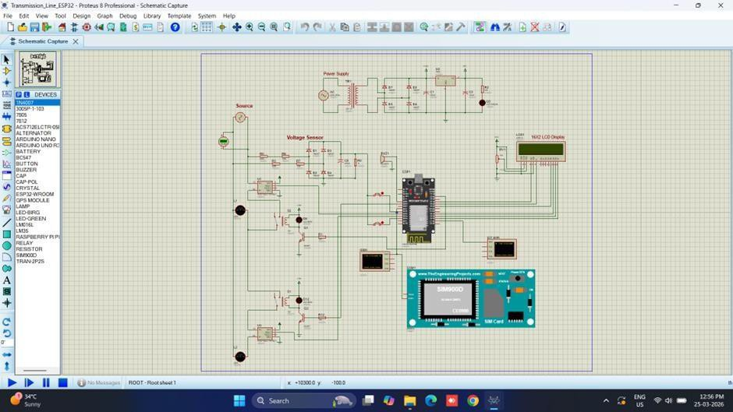

Figure 5.7 Simulation Circuit Diagram in Proteus

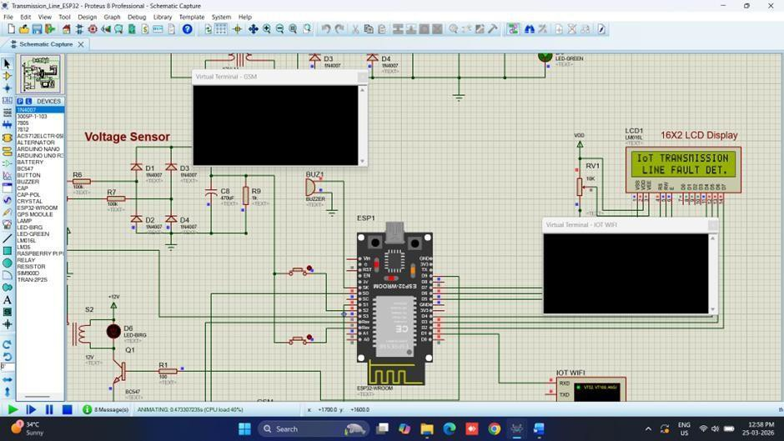

Figure 5.8 Simulation Setup of Transmission Line Fault Detection system
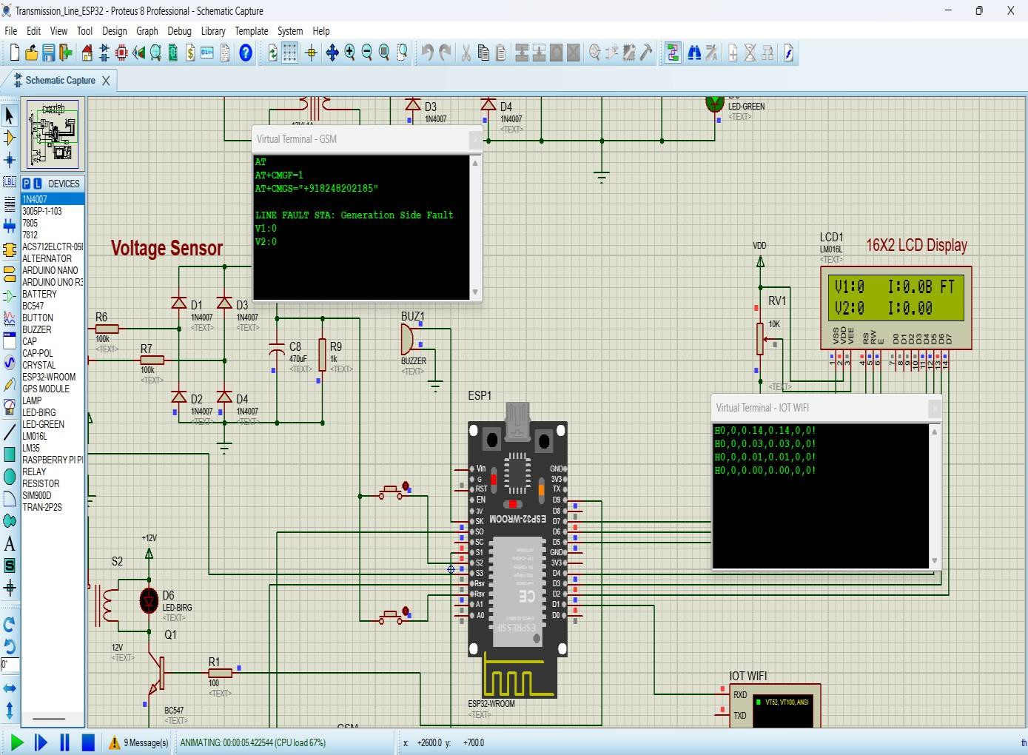

Figure 5.9 Generation Side Fault Simulation output

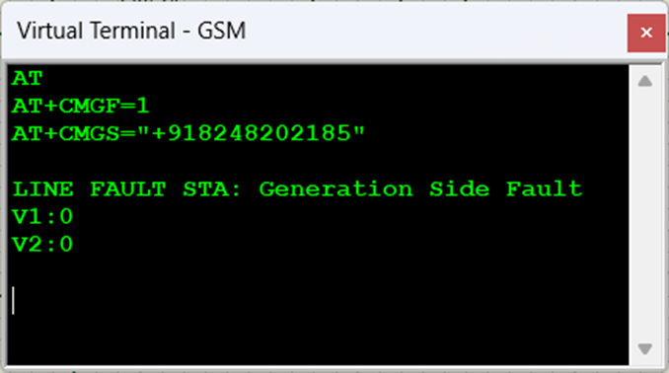

Figure 5.10 GSM Alert Output During Generation Side Fault Condition
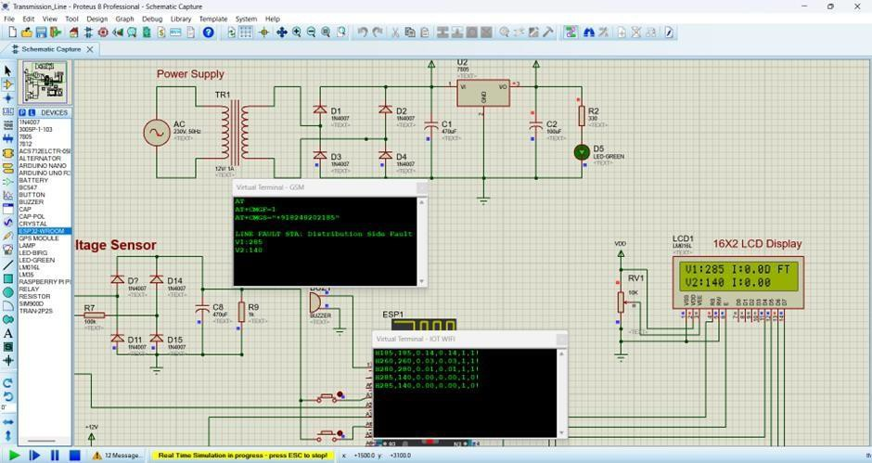

Figure 5.11 Distribution Side Fault Simulation Output

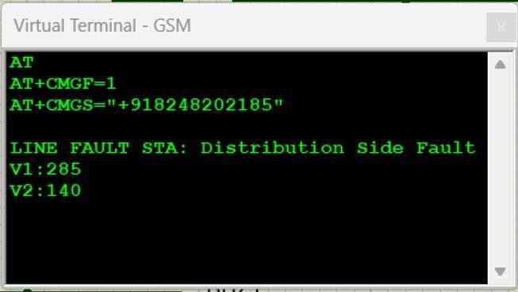

Figure 5.12 GSM Alert Output During Distribution Side Fault Condition

The above figures illustrate the simulation of the proposed IoT-based transmission line fault detection system using Proteus software. The simulation was carried out under different conditions including normal operation, generation side fault, and distribution side fault. The results demonstrate that the system successfully detects faults based on voltage and current variations and provides appropriate outputs. The GSM module simulation confirms that alert messages are generated during fault conditions, ensuring effective communication. Overall, the simulation validates the functionality and accuracy of the proposed system before hardware implementation.

  - Output Using ThingSpeak
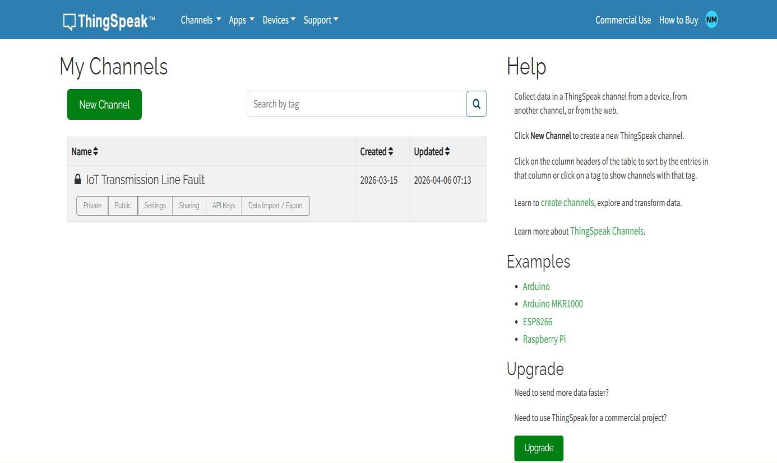

Figure 5.13 ThingSpeak Channel Setup for IoT Transmission Line Fault System
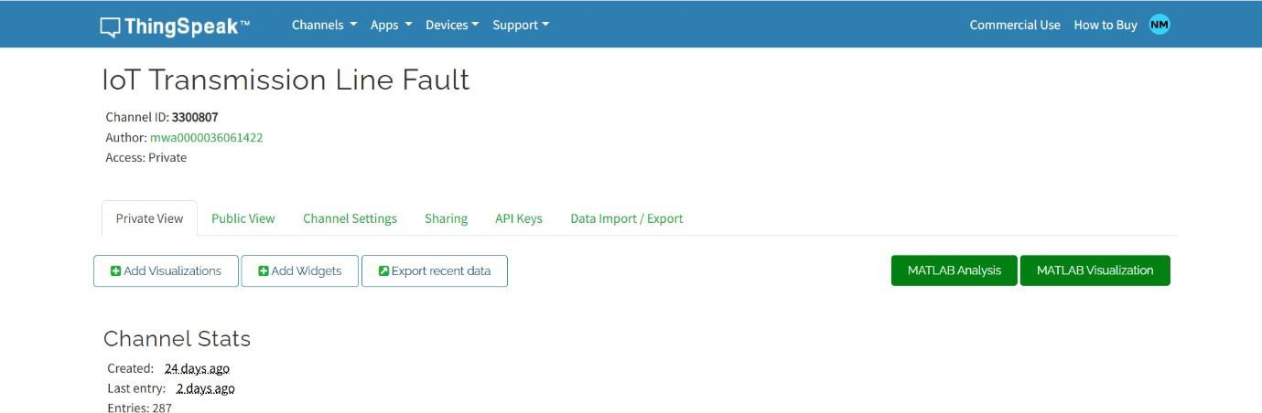

Figure 5.14 IoT Cloud Monitoring Dashboard in ThingSpeak

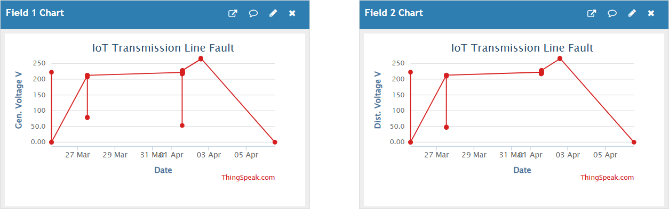

Figure 5.15 Voltage Graph Analysis (Generation and Distribution Side)

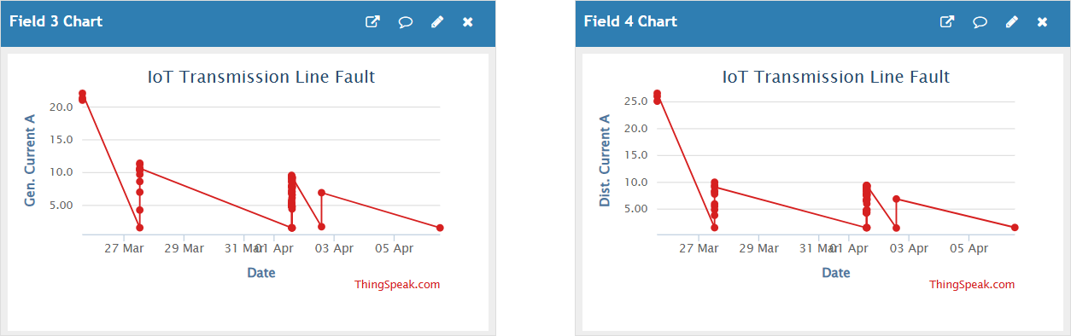

Figure 5.16 Current Graph Analysis (Generation and Distribution Side)

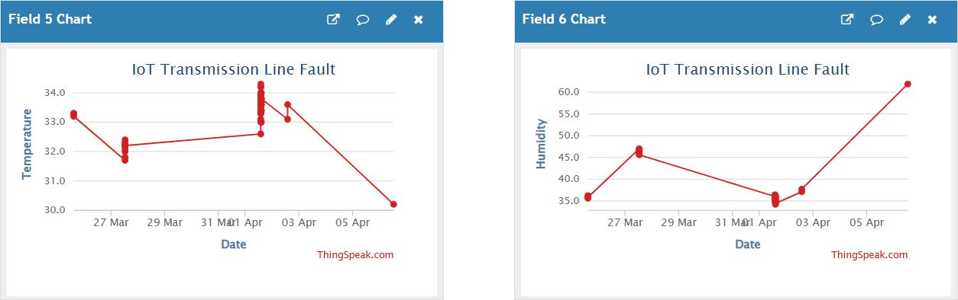

Figure 5.17 Temperature and Humidity Analysis using DHT11 Sensor

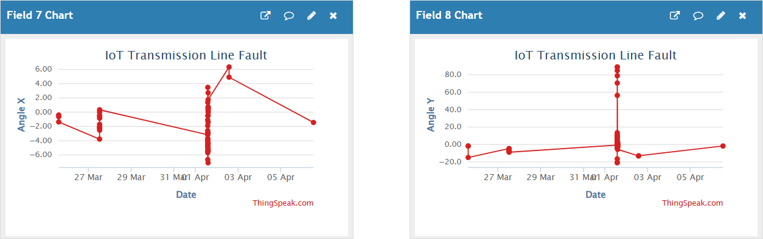

Figure 5.18 Tilt Angle Analysis using MPU6050 Sensor (X and Y Axis)

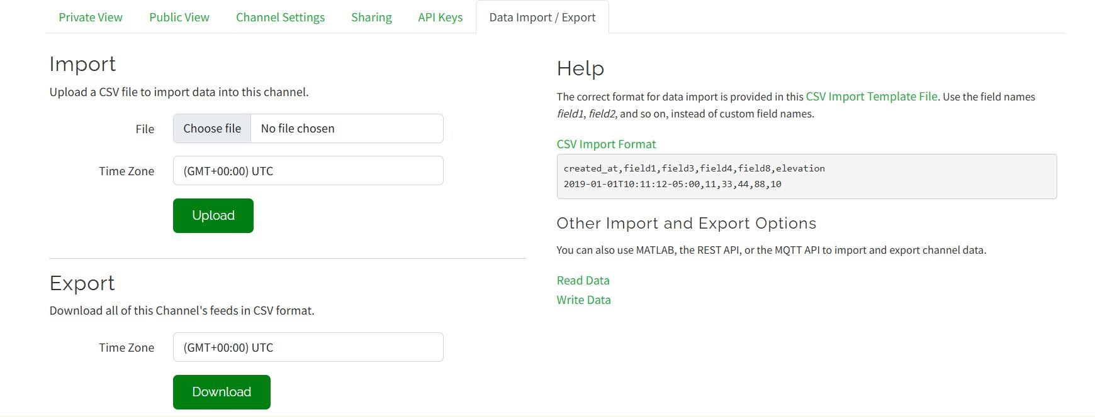

Figure 5.19 Data Import and Export Options in ThingSpeak

The above figures represent the IoT-based monitoring of the proposed transmission line fault detection system using the ThingSpeak cloud platform. The system continuously uploads real-time data such as voltage, current, temperature, humidity, and tilt angle to the cloud. The graphical representation of these parameters helps in easy visualization and analysis of system performance under different conditions. During fault conditions, noticeable variations can be observed in voltage and current graphs, indicating abnormalities in the transmission line. Environmental parameters such as temperature and humidity provide additional insights into system behavior. The tilt angle analysis using the MPU6050 sensor helps in detecting physical disturbances in the transmission line. The data collected from the ThingSpeak platform can be exported in CSV format and analyzed using Microsoft Excel for further evaluation. Overall, the system enables efficient remote monitoring and enhances the reliability of the power transmission system.

Live Video Monitoring using ESP32-CAM Module
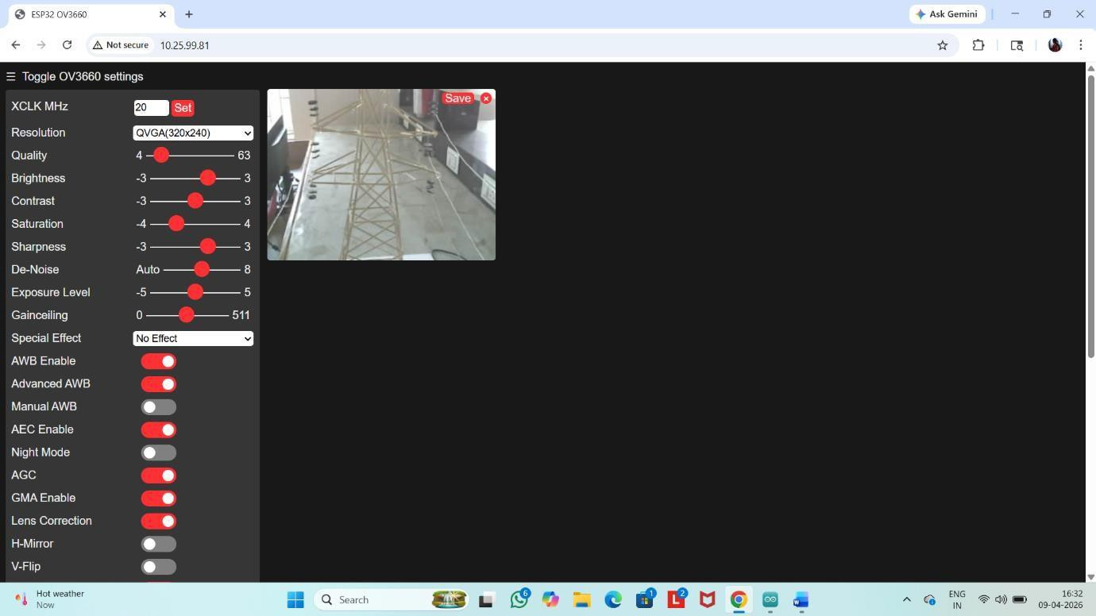

Figure 5.20 Live Video Monitoring using ESP32-CAM Module
The above figure shows the live video monitoring interface of the ESP32-CAM module. The camera module captures real-time images and streams video of the transmission line setup through a web server. This feature enables remote visual monitoring of the system and helps in identifying physical faults such as sparks, damage, or external disturbances. The integration of the ESP32-CAM enhances the overall monitoring capability of the system by providing both data-based and visual analysis.

GSM Alert Message during Fault Condition
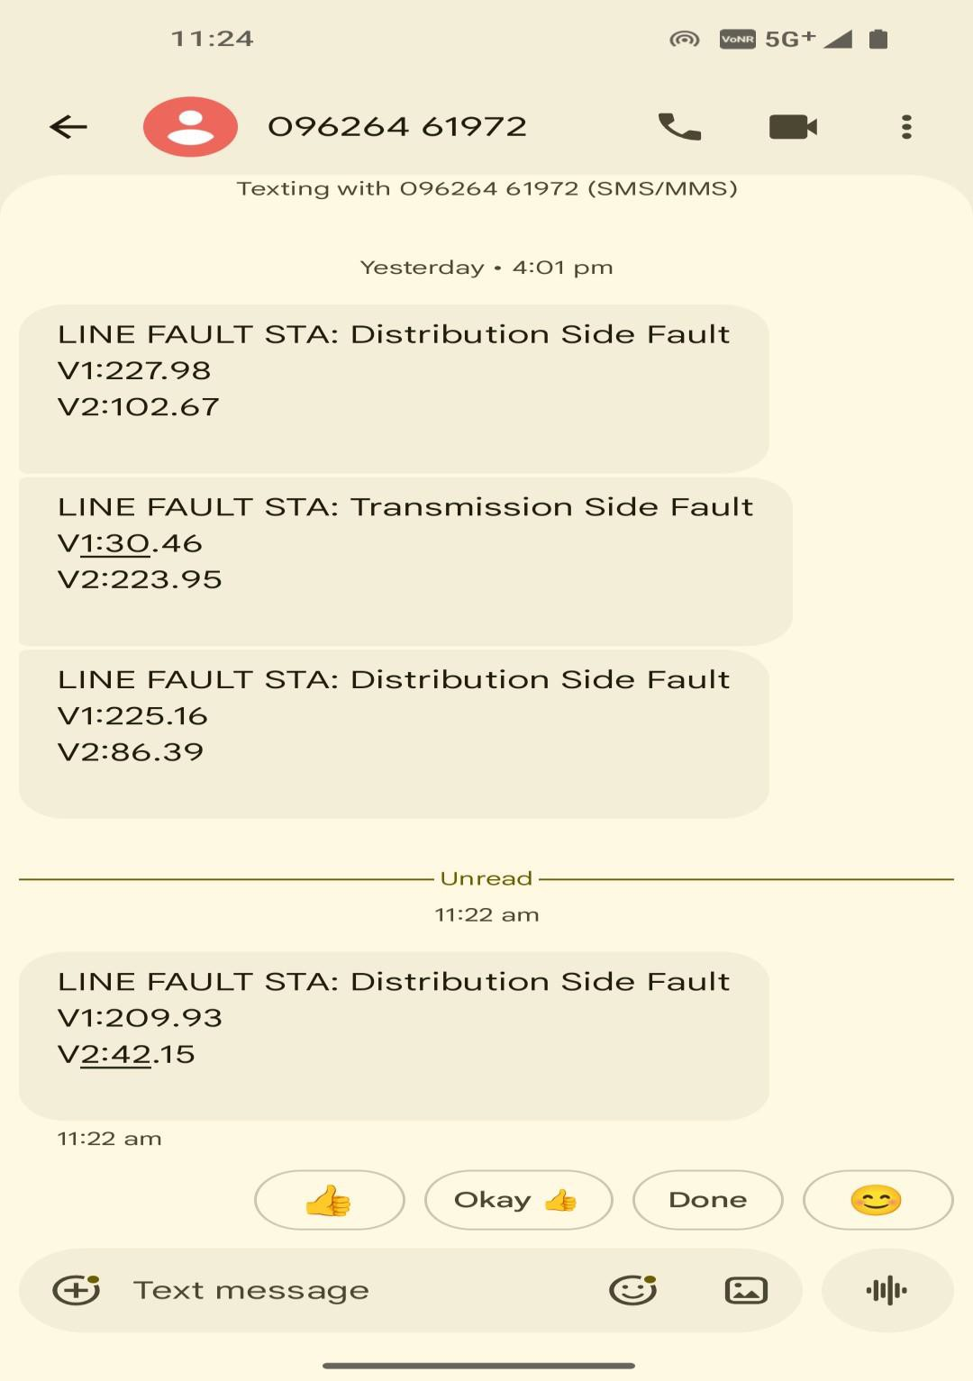

Figure 5.21 GSM Alert Message during Fault Condition

The above figure shows the alert message sent by the GSM module during fault conditions. When a fault is detected, the system immediately sends an SMS containing fault type and voltage values to the user. This ensures quick notification and enables timely action to prevent further damage.

CHAPTER 6

RESULTS AND DISCUSSION
The implementation of the proposed IoT-based transmission line monitoring system demonstrates significant improvements in fault detection accuracy, response time, and overall system reliability. The system was tested under various simulated fault conditions, including overcurrent, voltage fluctuations, leakage currents, and environmental variations. The voltage and current sensing modules successfully provided continuous real-time data to the ESP32 microcontroller, enabling precise monitoring of electrical parameters. By comparing input and output current values, the system efficiently detected leakage and imbalance conditions, which are critical indicators of transmission faults. The accuracy of fault detection was observed to be high, as the system responded immediately when predefined threshold values were exceeded.
During experimental evaluation, the relay module demonstrated effective fault isolation by disconnecting the load within milliseconds of fault detection. This rapid response significantly reduces the risk of equipment damage and enhances safety in the power system. The driver circuit ensured proper interfacing between the low-power ESP32 and the high- power relay, maintaining system stability. The LCD display provided clear and real-time visualization of parameters such as voltage, current, temperature, and system status, enabling easy local monitoring. Additionally, the buzzer alert system proved useful in drawing immediate attention to faults, especially in environments where constant visual monitoring is not feasible.
The integration of environmental sensors such as DHT11 and MPU6050 added a new dimension to system performance. It was observed that environmental conditions such as high temperature and humidity influenced the behavior of electrical components. By monitoring these parameters, the system was able to provide a more comprehensive analysis of fault conditions. The MPU6050 sensor effectively detected vibrations and movement, which could indicate mechanical disturbances or structural issues in transmission lines. This feature enhances the predictive maintenance capability of the system by identifying potential faults before they escalate into critical failures.
One of the most notable results of the system is the performance of the communication modules. The GSM module successfully transmitted alert messages to predefined mobile numbers immediately after fault detection, ensuring quick response from maintenance

personnel. The IoT functionality enabled seamless data uploading to a cloud platform, allowing users to monitor system parameters remotely in real time. This remote accessibility greatly improves operational efficiency, especially in large-scale power distribution networks where manual monitoring is challenging. The Wi-Fi capability of the ESP32 ensured stable and continuous connectivity, making the system suitable for modern smart grid applications.
The inclusion of the ESP32-CAM module significantly enhanced the monitoring capabilities of the system. During testing, the camera module successfully captured images and streamed video of the transmission line environment. This visual data proved highly valuable in verifying fault conditions, such as identifying physical damage, sparks, or external disturbances. The ability to remotely access visual information reduces the need for manual inspection, thereby saving time and operational costs. Moreover, the event-based triggering mechanism ensured efficient use of bandwidth by capturing images only during abnormal conditions.
Overall, the results indicate that the proposed system is highly effective in providing real-time monitoring, accurate fault detection, and rapid response. The combination of electrical sensing, environmental monitoring, communication technologies, and visual surveillance creates a robust and intelligent system capable of addressing the limitations of conventional monitoring methods. The system not only improves safety and reliability but also supports predictive maintenance and remote management, making it a suitable solution for modern power transmission and distribution networks.

CHAPTER 7

CONCLUSION
The developed IoT-based transmission line monitoring and fault detection system successfully demonstrates an efficient, reliable, and intelligent approach to modern power system supervision. By integrating the ESP32 microcontroller with voltage and current sensing modules, the system is capable of continuously monitoring electrical parameters and identifying faults such as overcurrent, voltage fluctuations, and leakage conditions in real time. The implementation of dual current sensing provides improved accuracy in fault detection by comparing input and output values, ensuring that even minor abnormalities are detected at an early stage. This significantly enhances the safety and protection of electrical equipment and reduces the chances of severe system failures.
The inclusion of environmental sensors such as DHT11 and MPU6050 adds an additional layer of intelligence to the system by enabling the monitoring of temperature, humidity, and physical disturbances. These parameters play a crucial role in understanding the overall condition of the transmission line and help in predicting potential faults before they occur. The integration of the ESP32-CAM further strengthens the system by providing visual monitoring, allowing users to verify fault conditions remotely and make informed maintenance decisions. This combination of electrical and environmental monitoring creates a comprehensive and robust fault detection mechanism. Another key strength of the system is its real-time communication capability.
The GSM module ensures instant alert notifications to users during fault conditions, while the IoT functionality enables continuous data uploading to cloud platforms for remote monitoring. This reduces dependency on manual inspection and allows quick response to issues, thereby improving operational efficiency. The presence of an LCD display and buzzer also supports local monitoring and immediate alerting, making the system user-friendly and effective in both remote and on-site environments. Overall, the proposed system provides a cost-effective, scalable, and smart solution for transmission line monitoring. It enhances system reliability, reduces maintenance time, and improves fault management through automation and real-time data access. The integration of sensing, control, communication, and monitoring technologies into a single platform makes it highly suitable for modern smart grid and IoT-based power management applications.

CHAPTER 8

REFERENCES
    - Madhan, V. P., et al. "Transmission Line Protection and Hybrid Fault Detection Using IOT." 2025 3rd International Conference on Artificial Intelligence and Machine Learning Applications Theme: Healthcare and Internet of Things (AIMLA). IEEE, 2025.
    - Sahu, Rupesh, et al. "Performance Assessment of Transmission Line Faults in Power System." 2025 IEEE 14th International Conference on Communication Systems and Network Technologies (CSNT). IEEE, 2025.
    - Behera, Saswati Kumari, et al. "Fault detection in transmission line by using IoT." 2024 International Conference on Power, Energy, Control and Transmission Systems (ICPECTS). IEEE, 2024.
    - Alam, Md Nahidul, et al. "Enhancing power grid reliability in Bangladesh: An IoT- based approach to transmission line fault detection." 2024 IEEE 3rd International Conference on Robotics, Automation, Artificial-Intelligence and Internet-of-Things (RAAICON). IEEE, 2024.
    - Almusawi, Muntather, et al. "Transmission Line Fault Detection and Classification Using Feature Extraction Based Self-Attention Convolutional Neural Network with Time Series Image." 2024 Third International Conference on Distributed Computing and Electrical Circuits and Electronics (ICDCECE). IEEE, 2024.
    - Firos, A., et al. "Fault detection in power transmission lines using AI model." 2023 IEEE International Conference on Integrated Circuits and Communication Systems (ICICACS). IEEE, 2023.
    - Biswas, Sauvik, et al. "A single-pole filter-assisted improved protection scheme for the TCSC-compensated transmission line connecting large-scale wind farms." IEEE Journal of Emerging and selected topics in industrial electronics 5.2 (2023): 346-358.
    - D. Lu, Y. Liu, and D. Lu, ‘‘An iterative parameter-free fault location method on three- terminal untransposed transmission lines,’’ in Proc. IEEE Power Energy Soc. Gen. Meeting (PESGM), Montreal, QC, Canada, Aug. 2020, pp. 1–5.

